The Ass Carrying the Image

by Aesop

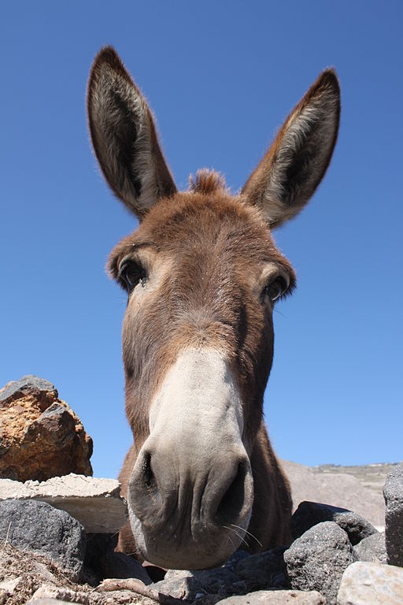Klearchos Kapoutsis, Santorini's Donkey, 2010
A certain man put an Image on the back of his Ass to take it to one of the temples of the town. As they went along the road all the people they met uncovered and bowed their heads out of reverence for the Image; but the Ass thought they were doing it out of respect for himself, and began to give himself airs accordingly. At last he became so conceited that he imagined he could do as he liked, and, by way of protest against the load he was carrying, he came to a full stop and flatly declined to proceed any further. His driver, finding him so obstinate, hit him hard and long with his stick, saying the while, "Oh, you dunder-headed idiot, do you suppose it's come to this, that men pay worship to an Ass?"
Rude shocks await those who take to themselves the credit that is due to others.

The Ass Carrying the Image

by Aesop

Klearchos Kapoutsis, Santorini's Donkey, 2010
A certain man put an Image on the back of his Ass to take it to one of the temples of the town. As they went along the road all the people they met uncovered and bowed their heads out of reverence for the Image; but the Ass thought they were doing it out of respect for himself, and began to give himself airs accordingly. At last he became so conceited that he imagined he could do as he liked, and, by way of protest against the load he was carrying, he came to a full stop and flatly declined to proceed any further. His driver, finding him so obstinate, hit him hard and long with his stick, saying the while, "Oh, you dunder-headed idiot, do you suppose it's come to this, that men pay worship to an Ass?"
Rude shocks await those who take to themselves the credit that is due to others.

