The Bat, the Bramble, and the Seagull

by Aesop

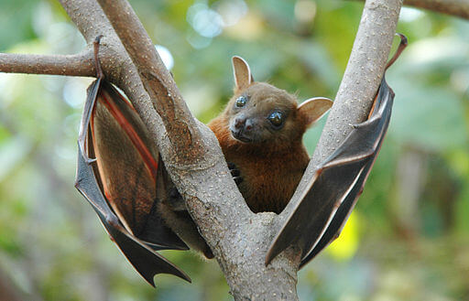Anton Croos, Short-Nosed Fruit Bat, Sri Lanka
A Bat, a Bramble, and a Seagull went into partnership and determined to go on a trading voyage together. The Bat borrowed a sum of money for his venture; the Bramble laid in a stock of clothes of various kinds; and the Seagull took a quantity of lead: and so they set out. By and by a great storm came on, and their boat with all the cargo went to the bottom, but the three travellers managed to reach land. Ever since then the Seagull flies to and fro over the sea, and every now and then dives below the surface, looking for the lead he's lost; while the Bat is so afraid of meeting his creditors that he hides away by day and only comes out at night to feed; and the Bramble catches hold of the clothes of every one who passes by, hoping some day to recognize and recover the lost garments.
All men are more concerned to recover what they lose than to acquire what they lack.

The Bat, the Bramble, and the Seagull

by Aesop

Anton Croos, Short-Nosed Fruit Bat, Sri Lanka
A Bat, a Bramble, and a Seagull went into partnership and determined to go on a trading voyage together. The Bat borrowed a sum of money for his venture; the Bramble laid in a stock of clothes of various kinds; and the Seagull took a quantity of lead: and so they set out. By and by a great storm came on, and their boat with all the cargo went to the bottom, but the three travellers managed to reach land. Ever since then the Seagull flies to and fro over the sea, and every now and then dives below the surface, looking for the lead he's lost; while the Bat is so afraid of meeting his creditors that he hides away by day and only comes out at night to feed; and the Bramble catches hold of the clothes of every one who passes by, hoping some day to recognize and recover the lost garments.
All men are more concerned to recover what they lose than to acquire what they lack.

