The Boy And The Nettle

by Aesop

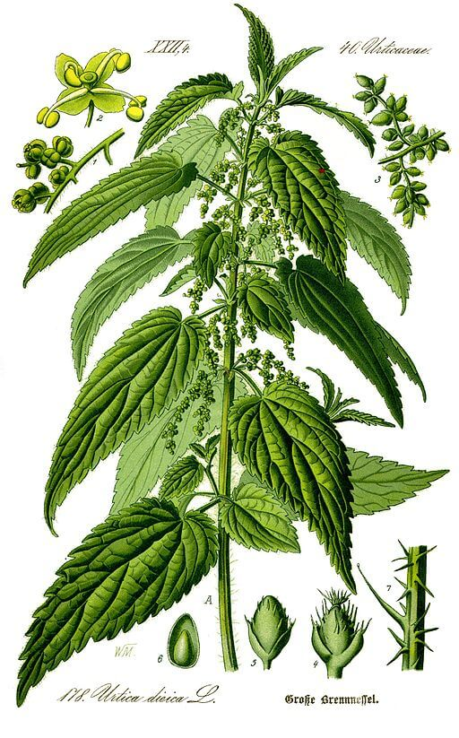Dr. Otto Wilhelm Thomé, Flora of Germany, Urtica Dioica, 1885
A Boy, stung by a Nettle, ran home crying, to get his mother to blow on the hurt and kiss it.
"Son," said the Boy's mother, when she had comforted him, "the next time you come near a Nettle, grasp it firmly, and it will be as soft as silk."
Whatever you do, do with all your might.

The Boy And The Nettle

by Aesop

Dr. Otto Wilhelm Thomé, Flora of Germany, Urtica Dioica, 1885
A Boy, stung by a Nettle, ran home crying, to get his mother to blow on the hurt and kiss it.
"Son," said the Boy's mother, when she had comforted him, "the next time you come near a Nettle, grasp it firmly, and it will be as soft as silk."
Whatever you do, do with all your might.

