The Boy Bathing

by Aesop

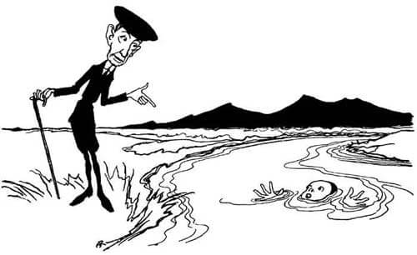
A Boy was bathing in a river and got out of his depth, and was in great danger of being drowned. A man who was passing along a road heard his cries for help, and went to the riverside and began to scold him for being so careless as to get into deep water, but made no attempt to help him. "Oh, sir," cried the Boy, "please help me first and scold me afterwards."
Give assistance, not advice, in a crisis.

The Boy Bathing

by Aesop

A Boy was bathing in a river and got out of his depth, and was in great danger of being drowned. A man who was passing along a road heard his cries for help, and went to the riverside and began to scold him for being so careless as to get into deep water, but made no attempt to help him. "Oh, sir," cried the Boy, "please help me first and scold me afterwards."
Give assistance, not advice, in a crisis.

