The Cock And The Jewel

by Aesop
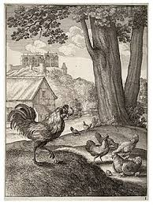

A Cock was busily scratching and scraping about to find something to eat for himself and his family, when he happened to turn up a precious jewel that had been lost by its owner.
"Aha!" said the Cock. "No doubt you are very costly and he who lost you would give a great deal to find you. But as for me, I would choose a single grain of barleycorn before all the jewels in the world."
Precious things are without value to those who cannot prize them.

The Cock And The Jewel

by Aesop

A Cock was busily scratching and scraping about to find something to eat for himself and his family, when he happened to turn up a precious jewel that had been lost by its owner.
"Aha!" said the Cock. "No doubt you are very costly and he who lost you would give a great deal to find you. But as for me, I would choose a single grain of barleycorn before all the jewels in the world."
Precious things are without value to those who cannot prize them.

