Rikki-Tikki-Tavi

by Rudyard Kipling

Rikki-Tikki-Tavi was inspired by the ancient Indian fables in the Panchatantra, Book Five.

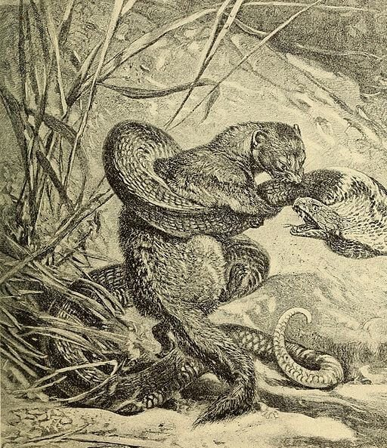
At the hole where he went in
Red-Eye called to Wrinkle-Skin.
Hear what little Red-Eye saith:
"Nag, come up and dance with death!"
Eye to eye and head to head,
(Keep the measure, Nag.)
This shall end when one is dead;
(At thy pleasure, Nag.)
Turn for turn and twist for twist--
(Run and hide thee, Nag.)
Hah! The hooded Death has missed!
(Woe betide thee, Nag!)
This is the story of the great war that Rikki-tikki-tavi fought single-handed through the bath-rooms of the big bungalow in Segowlee cantonment. Darzee, the Tailorbird, helped him, and Chuchundra, the musk-rat, who never comes out into the middle of the floor, but always creeps round by the wall, gave him advice, but Rikki-tikki did the real fighting. He was a mongoose, rather like a little cat in his fur and his tail, but quite like a weasel in his head and his habits. His eyes and the end of his restless nose were pink. He could scratch himself anywhere he pleased with any leg, front or back, that he chose to use. He could fluff up his tail till it looked like a bottle brush, and his war cry as he scuttled through the long grass was: "Rikk-tikk-tikki-tikki-tchk!" One day, a high summer flood washed him out of the burrow where he lived with his father and mother, and carried him, kicking and clucking, down a roadside ditch. He found a little wisp of grass floating there, and clung to it till he lost his senses. When he revived, he was lying in the hot sun on the middle of a garden path, very draggled indeed, and a small boy was saying, "Here's a dead mongoose. Let's have a funeral." "No," said his mother, "let's take him in and dry him. Perhaps he isn't really dead." They took him into the house, and a big man picked him up between his finger and thumb and said he was not dead but half choked. So they wrapped him in cotton wool, and warmed him over a little fire, and he opened his eyes and sneezed. "Now," said the big man (he was an Englishman who had just moved into the bungalow), "don't frighten him, and we'll see what he'll do." It is the hardest thing in the world to frighten a mongoose, because he is eaten up from nose to tail with curiosity. The motto of all the mongoose family is "Run and find out," and Rikki-tikki was a true mongoose. He looked at the cotton wool, decided that it was not good to eat, ran all round the table, sat up and put his fur in order, scratched himself, and jumped on the small boy's shoulder. "Don't be frightened, Teddy," said his father.
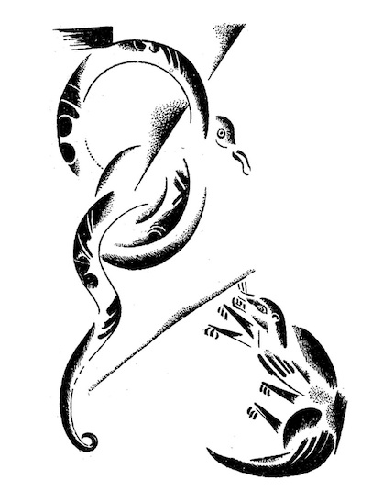"That's his way of making friends." "Ouch! He's tickling under my chin," said Teddy.
Rikki-tikki looked down between the boy's collar and neck, snuffed at his ear, and climbed down to the floor, where he sat rubbing his nose. "Good gracious," said Teddy's mother, "and that's a wild creature! I suppose he's so tame because we've been kind to him." "All mongooses are like that," said her husband. "If Teddy doesn't pick him up by the tail, or try to put him in a cage, he'll run in and out of the house all day long. Let's give him something to eat." They gave him a little piece of raw meat. Rikki-tikki liked it immensely, and when it was finished he went out into the veranda and sat in the sunshine and fluffed up his fur to make it dry to the roots. Then he felt better. "There are more things to find out about in this house," he said to himself, "than all my family could find out in all their lives. I shall certainly stay and find out." He spent all that day roaming over the house. He nearly drowned himself in the bath-tubs, put his nose into the ink on a writing table, and burned it on the end of the big man's cigar, for he climbed up in the big man's lap to see how writing was done. At nightfall he ran into Teddy's nursery to watch how kerosene lamps were lighted, and when Teddy went to bed Rikki-tikki climbed up too. But he was a restless companion, because he had to get up and attend to every noise all through the night, and find out what made it. Teddy's mother and father came in, the last thing, to look at their boy, and Rikki-tikki was awake on the pillow. "I don't like that," said Teddy's mother. "He may bite the child." "He'll do no such thing," said the father. "Teddy's safer with that little beast than if he had a bloodhound to watch him. If a snake came into the nursery now--" But Teddy's mother wouldn't think of anything so awful. Early in the morning Rikki-tikki came to early breakfast in the veranda riding on Teddy's shoulder, and they gave him banana and some boiled egg. He sat on all their laps one after the other, because every well-brought-up mongoose always hopes to be a house mongoose some day and have rooms to run about in; and Rikki-tikki's mother (she used to live in the general's house at Segowlee) had carefully told Rikki what to do if ever he came across white men. Then Rikki-tikki went out into the garden to see what was to be seen. It was a large garden, only half cultivated, with bushes, as big as summer-houses, of Marshal Niel roses, lime and orange trees, clumps of bamboos, and thickets of high grass. Rikki-tikki licked his lips. "This is a splendid hunting-ground," he said, and his tail grew bottle-brushy at the thought of it, and he scuttled up and down the garden, snuffing here and there till he heard very sorrowful voices in a thorn-bush. It was Darzee, the Tailorbird, and his wife. They had made a beautiful nest by pulling two big leaves together and stitching them up the edges with fibers, and had filled the hollow with cotton and downy fluff. The nest swayed to and fro, as they sat on the rim and cried. "What is the matter?" asked Rikki-tikki. "We are very miserable," said Darzee. "One of our babies fell out of the nest yesterday and Nag ate him." "H'm!" said Rikki-tikki, "that is very sad--but I am a stranger here. Who is Nag?" Darzee and his wife only cowered down in the nest without answering, for from the thick grass at the foot of the bush there came a low hiss--a horrid cold sound that made Rikki-tikki jump back two clear feet. Then inch by inch out of the grass rose up the head and spread hood of Nag, the big black cobra, and he was five feet long from tongue to tail. When he had lifted one-third of himself clear of the ground, he stayed balancing to and fro exactly as a dandelion tuft balances in the wind, and he looked at Rikki-tikki with the wicked snake's eyes that never change their expression, whatever the snake may be thinking of. "Who is Nag?" said he. "I am Nag. The great God Brahm put his mark upon all our people, when the first cobra spread his hood to keep the sun off Brahm as he slept. Look, and be afraid!" He spread out his hood more than ever, and Rikki-tikki saw the spectacle-mark on the back of it that looks exactly like the eye part of a hook-and-eye fastening. He was afraid for the minute, but it is impossible for a mongoose to stay frightened for any length of time, and though Rikki-tikki had never met a live cobra before, his mother had fed him on dead ones, and he knew that all a grown mongoose's business in life was to fight and eat snakes. Nag knew that too and, at the bottom of his cold heart, he was afraid. "Well," said Rikki-tikki, and his tail began to fluff up again, "marks or no marks, do you think it is right for you to eat fledglings out of a nest?" Nag was thinking to himself, and watching the least little movement in the grass behind Rikki-tikki. He knew that mongooses in the garden meant death sooner or later for him and his family, but he wanted to get Rikki-tikki off his guard. So he dropped his head a little, and put it on one side. "Let us talk," he said.
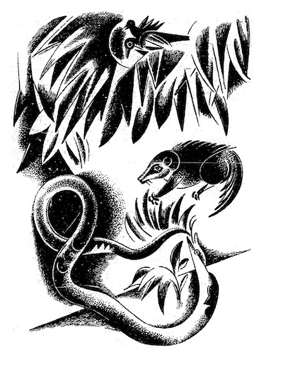"You eat eggs. Why should not I eat birds?" "Behind you! Look behind you!" sang Darzee.
Rikki-tikki knew better than to waste time in staring. He jumped up in the air as high as he could go, and just under him whizzed by the head of Nagaina, Nag's wicked wife. She had crept up behind him as he was talking, to make an end of him. He heard her savage hiss as the stroke missed. He came down almost across her back, and if he had been an old mongoose he would have known that then was the time to break her back with one bite; but he was afraid of the terrible lashing return stroke of the cobra. He bit, indeed, but did not bite long enough, and he jumped clear of the whisking tail, leaving Nagaina torn and angry.
"Wicked, wicked Darzee!" said Nag, lashing up as high as he could reach toward the nest in the thorn-bush. But Darzee had built it out of reach of snakes, and it only swayed to and fro. Rikki-tikki felt his eyes growing red and hot (when a mongoose's eyes grow red, he is angry), and he sat back on his tail and hind legs like a little kangaroo, and looked all round him, and chattered with rage. But Nag and Nagaina had disappeared into the grass. When a snake misses its stroke, it never says anything or gives any sign of what it means to do next. Rikki-tikki did not care to follow them, for he did not feel sure that he could manage two snakes at once. So he trotted off to the gravel path near the house, and sat down to think. It was a serious matter for him. If you read the old books of natural history, you will find they say that when the mongoose fights the snake and happens to get bitten, he runs off and eats some herb that cures him. That is not true. The victory is only a matter of quickness of eye and quickness of foot--snake's blow against mongoose's jump--and as no eye can follow the motion of a snake's head when it strikes, this makes things much more wonderful than any magic herb. Rikki-tikki knew he was a young mongoose, and it made him all the more pleased to think that he had managed to escape a blow from behind. It gave him confidence in himself, and when Teddy came running down the path, Rikki-tikki was ready to be petted. But just as Teddy was stooping, something wriggled a little in the dust, and a tiny voice said: "Be careful. I am Death!" It was Karait, the dusty brown snakeling that lies for choice on the dusty earth; and his bite is as dangerous as the cobra's. But he is so small that nobody thinks of him, and so he does the more harm to people. Rikki-tikki's eyes grew red again, and he danced up to Karait with the peculiar rocking, swaying motion that he had inherited from his family. It looks very funny, but it is so perfectly balanced a gait that you can fly off from it at any angle you please, and in dealing with snakes this is an advantage.
If Rikki-tikki had only known, he was doing a much more dangerous thing than fighting Nag, for Karait is so small, and can turn so quickly, that unless Rikki bit him close to the back of the head, he would get the return stroke in his eye or his lip. But Rikki did not know. His eyes were all red, and he rocked back and forth, looking for a good place to hold. Karait struck out. Rikki jumped sideways and tried to run in, but the wicked little dusty gray head lashed within a fraction of his shoulder, and he had to jump over the body, and the head followed his heels close. Teddy shouted to the house: "Oh, look here! Our mongoose is killing a snake." And Rikki-tikki heard a scream from Teddy's mother. His father ran out with a stick, but by the time he came up, Karait had lunged out once too far, and Rikki-tikki had sprung, jumped on the snake's back, dropped his head far between his forelegs, bitten as high up the back as he could get hold, and rolled away. That bite paralyzed Karait, and Rikki-tikki was just going to eat him up from the tail, after the custom of his family at dinner, when he remembered that a full meal makes a slow mongoose, and if he wanted all his strength and quickness ready, he must keep himself thin. He went away for a dust bath under the castor-oil bushes, while Teddy's father beat the dead Karait. "What is the use of that?" thought Rikki-tikki. "I have settled it all;" and then Teddy's mother picked him up from the dust and hugged him, crying that he had saved Teddy from death, and Teddy's father said that he was a providence, and Teddy looked on with big scared eyes. Rikki-tikki was rather amused at all the fuss, which, of course, he did not understand. Teddy's mother might just as well have petted Teddy for playing in the dust. Rikki was thoroughly enjoying himself. That night at dinner, walking to and fro among the wine-glasses on the table, he might have stuffed himself three times over with nice things. But he remembered Nag and Nagaina, and though it was very pleasant to be patted and petted by Teddy's mother, and to sit on Teddy's shoulder, his eyes would get red from time to time, and he would go off into his long war cry of "Rikk-tikk-tikki-tikki-tchk!" Teddy carried him off to bed, and insisted on Rikki-tikki sleeping under his chin. Rikki-tikki was too well bred to bite or scratch, but as soon as Teddy was asleep he went off for his nightly walk round the house, and in the dark he ran up against Chuchundra, the musk-rat, creeping around by the wall. Chuchundra is a broken-hearted little beast. He whimpers and cheeps all the night, trying to make up his mind to run into the middle of the room. But he never gets there. "Don't kill me," said Chuchundra, almost weeping. "Rikki-tikki, don't kill me!" "Do you think a snake-killer kills muskrats?" said Rikki-tikki scornfully.
"Those who kill snakes get killed by snakes," said Chuchundra, more sorrowfully than ever. "And how am I to be sure that Nag won't mistake me for you some dark night?" "There's not the least danger," said Rikki-tikki. "But Nag is in the garden, and I know you don't go there." "My cousin Chua, the rat, told me--" said Chuchundra, and then he stopped.
"Told you what?" "H'sh! Nag is everywhere, Rikki-tikki. You should have talked to Chua in the garden." "I didn't--so you must tell me. Quick, Chuchundra, or I'll bite you!"
Chuchundra sat down and cried till the tears rolled off his whiskers. "I am a very poor man," he sobbed. "I never had spirit enough to run out into the middle of the room. H'sh! I mustn't tell you anything. Can't you hear, Rikki-tikki?" Rikki-tikki listened. The house was as still as still, but he thought he could just catch the faintest scratch-scratch in the world--a noise as faint as that of a wasp walking on a window-pane--the dry scratch of a snake's scales on brick-work. "That's Nag or Nagaina," he said to himself, "and he is crawling into the bath-room sluice. You're right, Chuchundra; I should have talked to Chua." He stole off to Teddy's bath-room, but there was nothing there, and then to Teddy's mother's bathroom. At the bottom of the smooth plaster wall there was a brick pulled out to make a sluice for the bath water, and as Rikki-tikki stole in by the masonry curb where the bath is put, he heard Nag and Nagaina whispering together outside in the moonlight. "When the house is emptied of people," said Nagaina to her husband, "he will have to go away, and then the garden will be our own again. Go in quietly, and remember that the big man who killed Karait is the first one to bite. Then come out and tell me, and we will hunt for Rikki-tikki together."
"But are you sure that there is anything to be gained by killing the people?" said Nag.
"Everything. When there were no people in the bungalow, did we have any mongoose in the garden? So long as the bungalow is empty, we are king and queen of the garden; and remember that as soon as our eggs in the melon bed hatch (as they may tomorrow), our children will need room and quiet." "I had not thought of that," said Nag. "I will go, but there is no need that we should hunt for Rikki-tikki afterward. I will kill the big man and his wife, and the child if I can, and come away quietly. Then the bungalow will be empty, and Rikki-tikki will go." Rikki-tikki tingled all over with rage and hatred at this, and then Nag's head came through the sluice, and his five feet of cold body followed it. Angry as he was, Rikki-tikki was very frightened as he saw the size of the big cobra. Nag coiled himself up, raised his head, and looked into the bathroom in the dark, and Rikki could see his eyes glitter. "Now, if I kill him here, Nagaina will know; and if I fight him on the open floor, the odds are in his favor. What am I to do?" said Rikki-tikki-tavi. Nag waved to and fro, and then Rikki-tikki heard him drinking from the biggest water-jar that was used to fill the bath. "That is good," said the snake.
"Now, when Karait was killed, the big man had a stick. He may have that stick still, but when he comes in to bathe in the morning he will not have a stick. I shall wait here till he comes. Nagaina--do you hear me?--I shall wait here in the cool till daytime." There was no answer from outside, so Rikki-tikki knew Nagaina had gone away. Nag coiled himself down, coil by coil, round the bulge at the bottom of the water jar, and Rikki-tikki stayed still as death. After an hour he began to move, muscle by muscle, toward the jar. Nag was asleep, and Rikki-tikki looked at his big back, wondering which would be the best place for a good hold.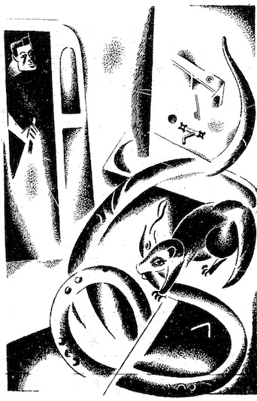"If I don't break his back at the first jump," said Rikki, "he can still fight. And if he fights--O Rikki!" He looked at the thickness of the neck below the hood, but that was too much for him; and a bite near the tail would only make Nag savage. "It must be the head"' he said at last; "the head above the hood. And, when I am once there, I must not let go." Then he jumped. The head was lying a little clear of the water jar, under the curve of it; and, as his teeth met, Rikki braced his back against the bulge of the red earthenware to hold down the head. This gave him just one second's purchase, and he made the most of it. Then he was battered to and fro as a rat is shaken by a dog--to and fro on the floor, up and down, and around in great circles, but his eyes were red and he held on as the body cart-whipped over the floor, upsetting the tin dipper and the soap dish and the flesh brush, and banged against the tin side of the bath. As he held he closed his jaws tighter and tighter, for he made sure he would be banged to death, and, for the honor of his family, he preferred to be found with his teeth locked. He was dizzy, aching, and felt shaken to pieces when something went off like a thunderclap just behind him. A hot wind knocked him senseless and red fire singed his fur. The big man had been wakened by the noise, and had fired both barrels of a shotgun into Nag just behind the hood. Rikki-tikki held on with his eyes shut, for now he was quite sure he was dead.
But the head did not move, and the big man picked him up and said, "It's the mongoose again, Alice. The little chap has saved our lives now." Then Teddy's mother came in with a very white face, and saw what was left of Nag, and Rikki-tikki dragged himself to Teddy's bedroom and spent half the rest of the night shaking himself tenderly to find out whether he really was broken into forty pieces, as he fancied. When morning came he was very stiff, but well pleased with his doings. "Now I have Nagaina to settle with, and she will be worse than five Nags, and there's no knowing when the eggs she spoke of will hatch. Goodness! I must go and see Darzee," he said. Without waiting for breakfast, Rikki-tikki ran to the thornbush where Darzee was singing a song of triumph at the top of his voice. The news of Nag's death was all over the garden, for the sweeper had thrown the body on the rubbish-heap. "Oh, you stupid tuft of feathers!" said Rikki-tikki angrily. "Is this the time to sing?" "Nag is dead--is dead--is dead!" sang Darzee.
"The valiant Rikki-tikki caught him by the head and held fast. The big man brought the bang-stick, and Nag fell in two pieces! He will never eat my babies again." "All that's true enough. But where's Nagaina?" said Rikki-tikki, looking carefully round him.
"Nagaina came to the bathroom sluice and called for Nag," Darzee went on, "and Nag came out on the end of a stick--the sweeper picked him up on the end of a stick and threw him upon the rubbish heap. Let us sing about the great, the red-eyed Rikki-tikki!" And Darzee filled his throat and sang. "If I could get up to your nest, I'd roll your babies out!"
said Rikki-tikki. "You don't know when to do the right thing at the right time. You're safe enough in your nest there, but it's war for me down here. Stop singing a minute, Darzee." "For the great, the beautiful Rikki-tikki's sake I will stop," said Darzee.
"What is it, O Killer of the terrible Nag?" "Where is Nagaina, for the third time?" "On the rubbish heap by the stables, mourning for Nag. Great is Rikki-tikki with the white teeth." "Bother my white teeth! Have you ever heard where she keeps her eggs?" "In the melon bed, on the end nearest the wall, where the sun strikes nearly all day. She hid them there weeks ago." "And you never thought it worth while to tell me? The end nearest the wall, you said?" "Rikki-tikki, you are not going to eat her eggs?" "Not eat exactly; no. Darzee, if you have a grain of sense you will fly off to the stables and pretend that your wing is broken, and let Nagaina chase you away to this bush. I must get to the melon-bed, and if I went there now she'd see me." Darzee was a feather-brained little fellow who could never hold more than one idea at a time in his head. And just because he knew that Nagaina's children were born in eggs like his own, he didn't think at first that it was fair to kill them. But his wife was a sensible bird, and she knew that cobra's eggs meant young cobras later on. So she flew off from the nest, and left Darzee to keep the babies warm, and continue his song about the death of Nag. Darzee was very like a man in some ways.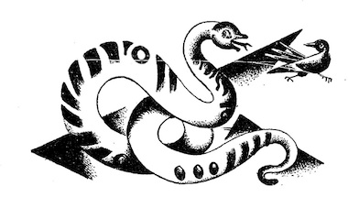She fluttered in front of Nagaina by the rubbish heap and cried out, "Oh, my wing is broken! The boy in the house threw a stone at me and broke it." Then she fluttered more desperately than ever. Nagaina lifted up her head and hissed, "You warned Rikki-tikki when I would have killed him. Indeed and truly, you've chosen a bad place to be lame in." And she moved toward Darzee's wife, slipping along over the dust. "The boy broke it with a stone!" shrieked Darzee's wife. "Well! It may be some consolation to you when you're dead to know that I shall settle accounts with the boy. My husband lies on the rubbish heap this morning, but before night the boy in the house will lie very still.
What is the use of running away? I am sure to catch you. Little fool, look at me!" Darzee's wife knew better than to do that, for a bird who looks at a snake's eyes gets so frightened that she cannot move. Darzee's wife fluttered on, piping sorrowfully, and never leaving the ground, and Nagaina quickened her pace. Rikki-tikki heard them going up the path from the stables, and he raced for the end of the melon patch near the wall.
There, in the warm litter above the melons, very cunningly hidden, he found twenty-five eggs, about the size of a bantam's eggs, but with whitish skin instead of shell. "I was not a day too soon," he said, for he could see the baby cobras curled up inside the skin, and he knew that the minute they were hatched they could each kill a man or a mongoose. He bit off the tops of the eggs as fast as he could, taking care to crush the young cobras, and turned over the litter from time to time to see whether he had missed any. At last there were only three eggs left, and Rikki-tikki began to chuckle to himself, when he heard Darzee's wife screaming: "Rikki-tikki, I led Nagaina toward the house, and she has gone into the veranda, and--oh, come quickly--she means killing!" Rikki-tikki smashed two eggs, and tumbled backward down the melon-bed with the third egg in his mouth, and scuttled to the veranda as hard as he could put foot to the ground. Teddy and his mother and father were there at early breakfast, but Rikki-tikki saw that they were not eating anything. They sat stone-still, and their faces were white. Nagaina was coiled up on the matting by Teddy's chair, within easy striking distance of Teddy's bare leg, and she was swaying to and fro, singing a song of triumph.
"Son of the big man that killed Nag," she hissed, "stay still. I am not ready yet. Wait a little. Keep very still, all you three! If you move I strike, and if you do not move I strike. Oh, foolish people, who killed my Nag!" Teddy's eyes were fixed on his father, and all his father could do was to whisper, "Sit still, Teddy. You mustn't move. Teddy, keep still." Then Rikki-tikki came up and cried, "Turn round, Nagaina. Turn and fight!" "All in good time," said she, without moving her eyes. "I will settle my account with you presently. Look at your friends, Rikki-tikki. They are still and white. They are afraid. They dare not move, and if you come a step nearer I strike." "Look at your eggs," said Rikki-tikki, "in the melon bed near the wall. Go and look, Nagaina!" The big snake turned half around, and saw the egg on the veranda. "Ah-h! Give it to me," she said. Rikki-tikki put his paws one on each side of the egg, and his eyes were blood-red.
"What price for a snake's egg? For a young cobra? For a young king cobra? For the last--the very last of the brood? The ants are eating all the others down by the melon bed." Nagaina spun clear round, forgetting everything for the sake of the one egg.
Rikki-tikki saw Teddy's father shoot out a big hand, catch Teddy by the shoulder, and drag him across the little table with the tea-cups, safe and out of reach of Nagaina.
"Tricked! Tricked! Tricked! Rikk-tck-tck!" chuckled Rikki-tikki. "The boy is safe, and it was I--I--I that caught Nag by the hood last night in the bathroom." Then he began to jump up and down, all four feet together, his head close to the floor. "He threw me to and fro, but he could not shake me off. He was dead before the big man blew him in two. I did it! Rikki-tikki-tck-tck! Come then, Nagaina. Come and fight with me. You shall not be a widow long." Nagaina saw that she had lost her chance of killing Teddy, and the egg lay between Rikki-tikki's paws. "Give me the egg, Rikki-tikki. Give me the last of my eggs, and I will go away and never come back," she said, lowering her hood. "Yes, you will go away, and you will never come back. For you will go to the rubbish heap with Nag. Fight, widow! The big man has gone for his gun! Fight!" Rikki-tikki was bounding all round Nagaina, keeping just out of reach of her stroke, his little eyes like hot coals.
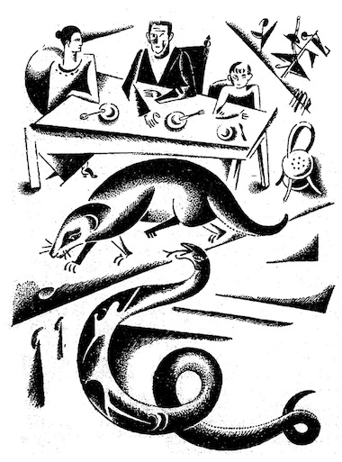Nagaina gathered herself together and flung out at him. Rikki-tikki jumped up and backward. Again and again and again she struck, and each time her head came with a whack on the matting of the veranda and she gathered herself together like a watch spring.
Then Rikki-tikki danced in a circle to get behind her, and Nagaina spun round to keep her head to his head, so that the rustle of her tail on the matting sounded like dry leaves blown along by the wind. He had forgotten the egg. It still lay on the veranda, and Nagaina came nearer and nearer to it, till at last, while Rikki-tikki was drawing breath, she caught it in her mouth, turned to the veranda steps, and flew like an arrow down the path, with Rikki-tikki behind her. When the cobra runs for her life, she goes like a whip-lash flicked across a horse's neck. Rikki-tikki knew that he must catch her, or all the trouble would begin again. She headed straight for the long grass by the thorn-bush, and as he was running Rikki-tikki heard Darzee still singing his foolish little song of triumph. But Darzee's wife was wiser. She flew off her nest as Nagaina came along, and flapped her wings about Nagaina's head. If Darzee had helped they might have turned her, but Nagaina only lowered her hood and went on. Still, the instant's delay brought Rikki-tikki up to her, and as she plunged into the rat-hole where she and Nag used to live, his little white teeth were clenched on her tail, and he went down with her--and very few mongooses, however wise and old they may be, care to follow a cobra into its hole. It was dark in the hole; and Rikki-tikki never knew when it might open out and give Nagaina room to turn and strike at him. He held on savagely, and stuck out his feet to act as brakes on the dark slope of the hot, moist earth. Then the grass by the mouth of the hole stopped waving, and Darzee said, "It is all over with Rikki-tikki! We must sing his death song. Valiant Rikki-tikki is dead! For Nagaina will surely kill him underground." So he sang a very mournful song that he made up on the spur of the minute, and just as he got to the most touching part, the grass quivered again, and Rikki-tikki, covered with dirt, dragged himself out of the hole leg by leg, licking his whiskers.
Darzee stopped with a little shout. Rikki-tikki shook some of the dust out of his fur and sneezed. "It is all over," he said. "The widow will never come out again." And the red ants that live between the grass stems heard him, and began to troop down one after another to see if he had spoken the truth. Rikki-tikki curled himself up in the grass and slept where he was--slept and slept till it was late in the afternoon, for he had done a hard day's work. "Now," he said, when he awoke, "I will go back to the house. Tell the Coppersmith, Darzee, and he will tell the garden that Nagaina is dead." The Coppersmith is a bird who makes a noise exactly like the beating of a little hammer on a copper pot; and the reason he is always making it is because he is the town crier to every Indian garden, and tells all the news to everybody who cares to listen. As Rikki-tikki went up the path, he heard his "attention" notes like a tiny dinner gong, and then the steady "Ding-dong-tock! Nag is dead--dong! Nagaina is dead! Ding-dong-tock!" That set all the birds in the garden singing, and the frogs croaking, for Nag and Nagaina used to eat frogs as well as little birds. When Rikki got to the house, Teddy and Teddy's mother (she looked very white still, for she had been fainting) and Teddy's father came out and almost cried over him; and that night he ate all that was given him till he could eat no more, and went to bed on Teddy's shoulder, where Teddy's mother saw him when she came to look late at night. "He saved our lives and Teddy's life," she said to her husband. "Just think, he saved all our lives." Rikki-tikki woke up with a jump, for the mongooses are light sleepers. "Oh, it's you," said he. "What are you bothering for? All the cobras are dead. And if they weren't, I'm here." Rikki-tikki had a right to be proud of himself. But he did not grow too proud, and he kept that garden as a mongoose should keep it, with tooth and jump and spring and bite, till never a cobra dared show its head inside the walls.

