اسم الطالبة :...................................................... الصف : الرابع الابتدائي/
Q1 - Choose:
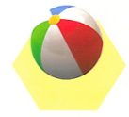
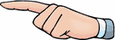
    - Those _ These ) are balls ).

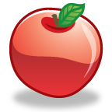
    - Those _ These ) are apple).

Q2- Write the correct word: (hat – shoes - thobe - dress )
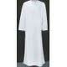 |  | 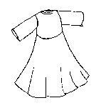 |  | 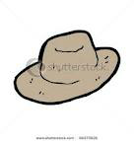

رقم المهاره | المهاره | اتقن | لم يتقن
24 | Read & match words to photos \ drawings.
Q5 - Read and match :

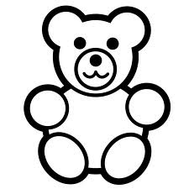
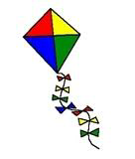
kite
cat
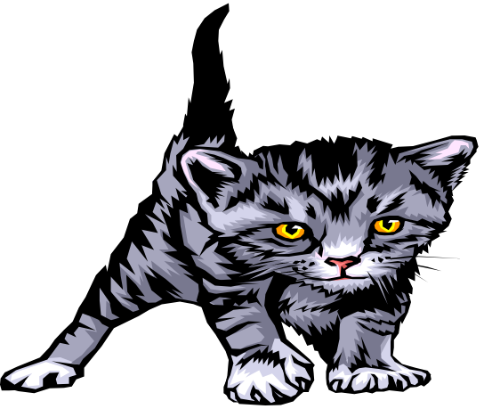
teddy bear
yo-yo

رقم المهارة | المهارة | اتقن | لم يتقن
34 | Do controlled writing such as supplying missing letters & words

Q6- Complete the missing letters:
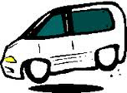 | ...an | 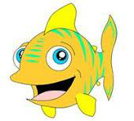  ...ish | 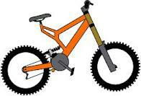  bi __ e

رقم المهارة | المهارة | اتقن | لم يتقن
30 | Copy words, numbers and simple short sentences.

Q7- Copy:
I love my father .

رقم المهارة | المهارة | اتقن | لم يتقن
33 | Write guided short answers to written questions
Q8- How many pens have you got?

I'v got 10 pens.

رقم المهاره | المهاره | اتقن | لم يتقن
35 | Recognize & apply the punctuation & capitalization assigned for this grade : (capitalizing the beginning of names , sentences , questions , & the use full stop & question mark
Q9 - Correct:
what's your name
----------------------------------------
my name is hassan
----------------------------------------------------------

