Match the words with the pictures.

A clown

B ringmaster

C juggler

D trapeze artist

E lions

F strongman

G horse

Match Words and Pictures  Match the word and pictures that start with the letters... -- a separate printable page for each letter of the alphabet. A, B, C, D, E, F, G, H, I, J, K, L, M, N, O, P, Q, R, S, St, T, U, V, W, X, Y, Z, or go to a pdf file containing all 26 printable A-Z pages (no x). | 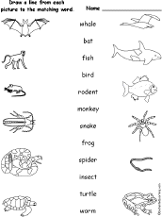  Match Animals to their Pictures  Match 10 animals to their pictures. The words are: whale, bat, fish, bird, rodent, monkey, snake, frog, spider, insect, turtle, worm. Or go to the answers. | 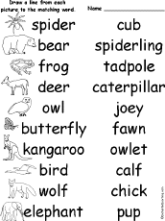  Match Animals and Their Babies  Match 10 animals to their babies. The animals are: spider, spiderling, bear, cub, frog, tadpole, deer, fawn, owl, owlet, butterfly, caterpillar, kangaroo, joey, bird, chick, wolf, cub, elephant, calf. Or go to the answers. | 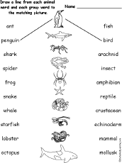  Match Animals and Their Groups #1  Match 10 animals to their pictures and the group they belong to. The animals/groups are: ant/insect, penguin/bird, shark/fish, spider/arachnid, frog/amphibian, snake/reptile, whale/mammal, starfish/echinoderm, lobster/crustacean, octopus/mollusk. Or go to the

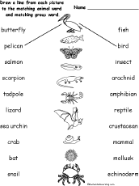  Match Animals and Their Groups #2  Match 10 animals to their pictures and the group they belong to. The animals/groups are: butterfly/insect, pelican/bird, salmon/fish, ,scorpion/arachnid, tadpole/amphibian, lizard/reptile, sea urchin/echinoderm, crab/crustacean, bat/mammal, snail/mollusk. Or go to the answers. | 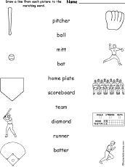  Match Baseball Words and Pictures  Match 10 baseball vocabulary words to their pictures. The words are: pitcher, ball, mitt, bat, home plate, scoreboard, team, diamond, runner, batter. Or go to the answers. | 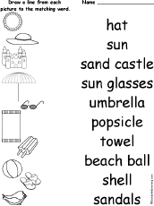  Beach Words Matching Printout  Draw lines between each beach word and its picture. The words are: hat, sun, sand castle, sun glasses, umbrella, popsicle, towel, beach ball, shell, sandals. Or go to the answers. | 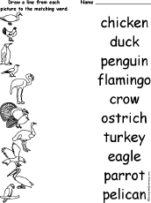  Match Birds and Pictures  Match 10 birds to their pictures. The words are: chicken, duck, penguin, flamingo, crow, ostrich, turkey, eagle, parrot, pelican. Or go to the answers.

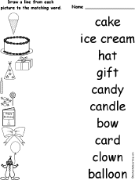  Match Birthday Words and Pictures  Match 10 birthday vocabulary words to their pictures. The words are: cake, ice cream, hat, gift, candy, candle, bow, card, balloon, clown. Or go to the answers. | 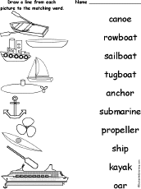  Boat Words Matching Printout  Draw lines between each boat word and its picture. The words are: canoe, rowboat, sailboat, tugboat, anchor, submarine, propeller, ship, kayak, oar. Or go to the answers. | 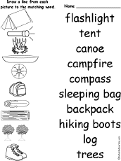  Match Camping Words and Pictures  Match 10 camping vocabulary words to their pictures. The words are: flashlight, tent, canoe, campfire, compass, sleeping bag, backpack, hiking boots, log, trees. Or go to the answers. | 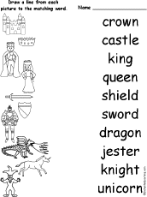  Match Castle Words and Pictures  Match 10 castle vocabulary words to their pictures. The words are: crown, castle, king, queen, shield, sword, dragon, jester, knight, unicorn. Or go to the answers.
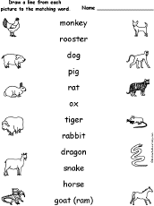  Match Chinese Zodiac Words and Pictures  Match 10 Chinese Zodiac animal words to their pictures. The words are: monkey, rooster, dog, pig, rat, ox, tiger, rabbit, dragon, snake, horse, goat (ram). Or go to the answers. | 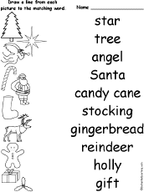  Match Christmas Words and Pictures  Match 10 Christmas vocabulary words to their pictures. The words are star, tree, angel Santa, candy cane, stocking, gingerbread, reindeer, holly, and gift. Or go to the answers. | 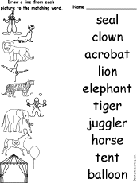  Match Circus Words and Pictures  Match 10 circus vocabulary words to their pictures. The words are: seal, clown, acrobat, lion, elephant, tiger, juggler, horse, tent, balloon. Or go to the answers. | 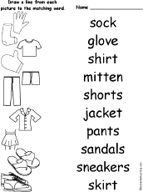  Match Clothing Words and Pictures #1  Match 10 clothing vocabulary words to their pictures. The words are sock, glove, shirt, mitten, shorts, jacket, pants, sandals, sneakers, skirt. Or go to the answers.
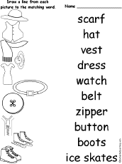  Match Clothing Words and Pictures #2  Match 10 clothing vocabulary words to their pictures. The words are scarf, hat, vest, dress, watch, belt, zipper, button, boots, ice skates. Or go to the answers. | 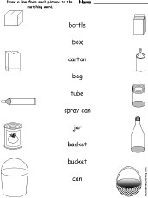  Match Container Words and Pictures  Match 10 container vocabulary words to their pictures. The words are: bottle, box, carton, bag, tube, spray can, jar, basket, bucket, can. Or go to the answers. | 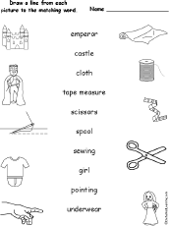  Match Words and Pictures from The Emperor's New Clothes  Match 10 vocabulary words to their pictures, the words are from the fairytale The Emperor's New Clothes. The words are: emperor, castle, cloth, tape measure, scissors, spool, sewing, girl, pointing, underwear. Or go to the answers. | 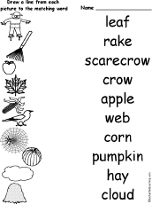  Match Fall Words and Pictures  Match 10 Fall vocabulary words to their pictures. The words are leaf, rake, scarecrow, crow, apple, web, corn, pumpkin, hay, and cloud. Or go to the answers.
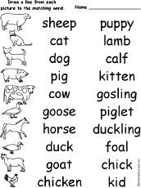  Match Farm Animals to their Babies  Match 10 farm animals words to their babies. The farm animals and babies are: sheep, lamb, cat, kitten, dog, puppy, pig, piglet, cow, calf, goose, gosling, horse, foal, duck, duckling, goat, kid, chicken, chick. Or go to the answers. | 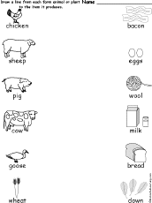  Match Farm Products  Match 10 farm animals and plants to the products they produce. The farm words are: chicken, sheep, pig, cow, goose, wheat, bacon, eggs, wool, milk, bread, down. Or go to the answers. | 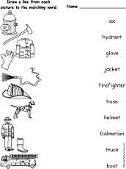  Match Firefighting Words and Pictures  Match 10 firefighting words. The words are: ax, hydrant, glove, jacket, firefighter, hose, helmet, Dalmatian, truck, boot. Or go to the answers. | 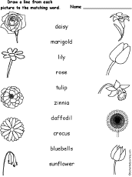  Match Flower Words and Pictures  Match 10 flowers to their pictures. The flowers are daisy, marigold, lily, rose, tulip, zinnia, daffodil, crocus, bluebells, sunflower. Or go to the answers.
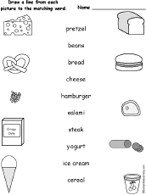  Match Food Words and Pictures  Match 10 food to their pictures. The words are pretzel, beans, bread, cheese, hamburger, salami, steak, yogurt, ice cream, and cereal. Or go to the answers. | 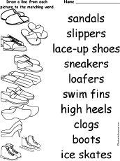  Match Footwear Words and Pictures  Match 10 footwear words. The words are: sandals, slippers, lace-up shoes, sneakers, loafers, swim fins, high heels, clogs, boots, ice skates. Or go to the answers. | 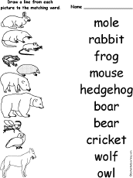  Match Forest Animals Words and Pictures  Match 10 forest animals to their pictures. The forest animals are mole, rabbit, frog, mouse, hedgehog, boar, cricket, wolf, owl. Or go to the answers. | 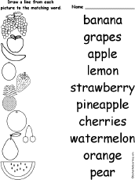  Match Fruit Words and Pictures  Match 10 fruits to their pictures. The fruit are banana, grapes, apple, lemon, strawberry, pineapple, cherries, watermelon, orange, and pear. Or go to the answers.
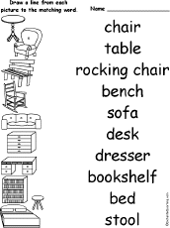  Match Furniture Words and Pictures  Match 10 furniture words. The words are: chair, table, rocking chair, bench, sofa, desk, dresser, bookshelf, bed, stool. Or go to the answers. | 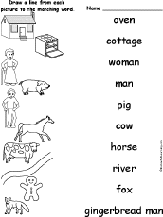  Match The Gingerbread Man Words and Pictures  Match 10 words from The Gingerbread Manstory to their pictures. The words are oven, cottage, woman, man, pig, cow, horse, river, fox, gingerbread man. Or go to the answers. | 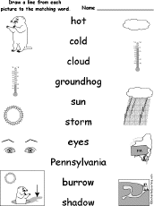  Match Groundhog Day Words and Pictures  Match 10 Groundhog Day words to their pictures. The words are hot, cold, cloud, groundhog, sun, storm, eyes, Pennsylvania, burrow, shadow. Or go to the answers. | 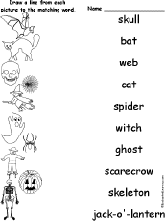  Match Halloween Words and Pictures  Match 10 Halloween words to their pictures. The words are skull, bat, web, cat, spider, witch, ghost, scarecrow, skeleton, jack-o'-lantern. Or go to the answers.
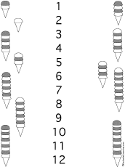  Ice Cream Scoops to Numbers Matching Printout  Draw lines between the ice cream cones that are have the same number of scoops as the numbers (from 1-12). Or go to the answers. | 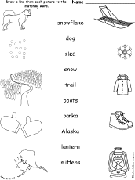  Match Iditarod Words and Pictures  Match 10 Iditarod words to their pictures. The words are snowflake, dog, sled, snow, trail, boots, parks, Alaska, lantern, mittens. Or go to the answers. | 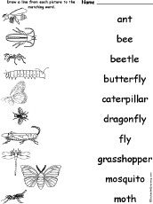  Match Insect Words and Pictures  Match 10 insect words to their pictures. The words are ant, bee, beetle, butterfly, caterpillar, dragonfly, fly, grasshopper, mosquito, moth. Or go to the answers. | 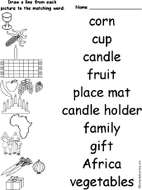  Match Kwanzaa Words and Pictures  Match 10 Kwanzaa vocabulary words to their pictures. The words are corn, cup, candle, fruit, place mat, candle holder, family, gift, Africa, and vegetables. Or go to the answers.
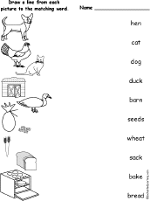  Match The Little Red Hen Words and Pictures  Match 10 words from The Little Red Hen story to their pictures. The words are hen, cat, dog, duck, barn, seeds, wheat, sack, bake, bread. Or go to the answers. | 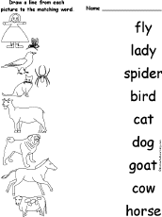  Match The Old Lady and the Fly Words and Pictures  Match 10 words from The Old Lady and the Fly story to their pictures. The words are fly, lady, spider, bird, cat, dog, goat, cow, horse. Or go to the answers. | 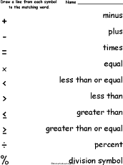  Match Math Symbol Words and Pictures  Match 10 math symbol words to their pictures. The words are: minus, plus, times, equal, less than equal, less than, greater than, greater than or equal, percent, division symbol. Or go to the answers. | 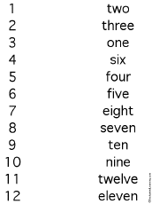  Numbers Matching Printout  Draw lines between the matching numbers. Or go to the answers.
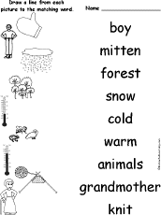  Match Mitten Words and Pictures  Match 10 words from The Mittenstory to their pictures. The forest animals are boy, mitten, forest, snow, cold, warm, animals, grandmother, knit. Or go to the answers. | 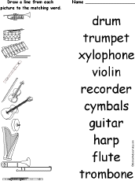  Match Musical Instruments:  Words and Pictures  Match 10 musical instruments words to their pictures. The words are: drum, trumpet, xylophone, violin, recorder, cymbals, guitar, harp, flute, trombone. Or go to the answers. | 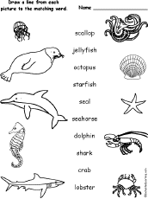  Match Ocean Animals  Match 10 ocean animal words to pictures. The ocean animal words are: scallop, jellyfish, octopus, starfish, seal, seahorse, dolphin, shark, crab, lobster. Or go to the answers. | 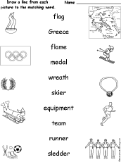  Match Olympics Words and Pictures  Match 10 Olympics vocabulary words to their pictures. The words are: flag, Greece, flame, medal, wreath, skier, equipment, team, runner, sledder. Or go to the answers.
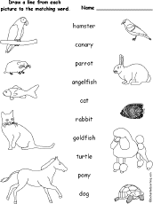  Match Pets to their Pictures  Match 10 pets to their pictures. The words are: hamster, canary, parrot, angelfish, cat, rabbit, goldfish, turtle, pony, dog. Or go to the answers. | 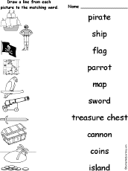  Match Pirate Words and Pictures  Match 10 pirate vocabulary words to their pictures. The words are: pirate, ship, flag, parrot, map, sword, treasure chest, cannon, coins, island. Or go to the answers. | 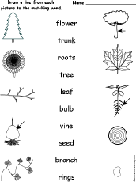  Match Plant Words to their Pictures  Match 10 plant-related words to their pictures. The words are: tree, trunk, flower, leaf, branch, roots, bulb, rings, vine, seed. Or go to the answers. | 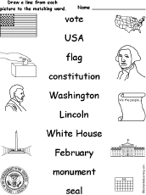  Match Presidents Day  Words and Pictures  Match 10 Presidents Day symbol words to their pictures. The words are: vote, USA, flag, constitution, Washington, Lincoln, White House, February, monument, seal. Or go to the answers.
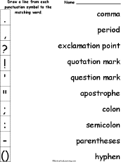  Match Punctuation Symbols:  Words and Pictures  Match 10 punctuation symbol words to their pictures. The words are: comma, period, exclamation point, quotation mark, question mark, apostrophe, colon, semicolon, parentheses, hyphen. Or go to the answers. | 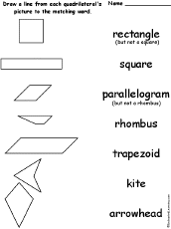  Quadrilaterals Matching Worksheet  Match each quadrilateral's picture to its name: rectangle, square, parallelogram, trapezoid, rhombus, kite, arrowhead. Or go to the answers. | 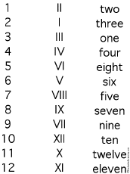  Roman Numerals Matching Printout  Draw lines between the matching Roman numerals and ordinary numbers. Or go to the answers. | 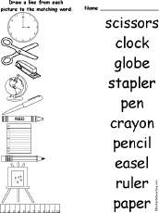  Match School Words and Pictures  Match 10 school vocabulary words to their pictures. The words are: scissors, clock, globe, stapler, pen, crayon, pencil, easel, ruler, paper. Or go to the answers.
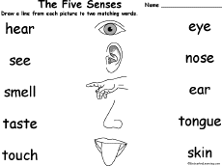  Match Senses Words and Pictures  Match 10 sense-related vocabulary words to their pictures. The words are: hear, see, smell, taste, touch, eye, nose, ear, tongue, skin. Or go to the answers. | 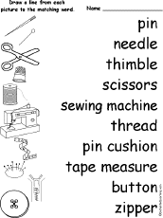  Match Sewing Words and Pictures  Match 10 sewing vocabulary words to their pictures. The words are: pin, needle, thimble, scissors, thread, sewing machine, pin cushion, taple measure, button, zipper. Or go to the answers. | 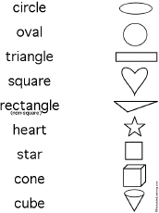  Shapes Matching Printout  Draw lines between the shapes and the words for the shapes. Or go to the answers. | 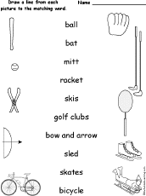  Match Sports Words and Pictures  Match 10 sports vocabulary words to their pictures. The words are: ball, bat, mitt, racket, skis, golf clubs, bow and arrow, sled, skates, bicycle. Or go to the answers.
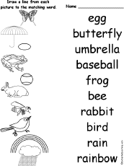  Match Spring Words and Pictures  Match 10 Spring vocabulary words to their pictures. The words are: egg, butterfly, umbrella, baseball, frog, bee, rabbit, bird, rain, rainbow. Or go to the answers. | 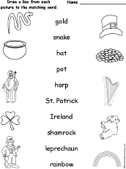  Match St. Patrick's Day Words and Pictures  Match 10 St. Patrick's Day vocabulary words to their pictures. The words are: gold, snake, hat, pot, harp, St. Patrick, Ireland, shamrock, leprechaun, rainbow. Or go to the answers. | 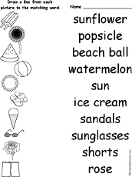  Match Summer Words and Pictures  Match 10 Summer vocabulary words to their pictures. The words are: sunflower, popsicle, beach ball, watermelon, sun, ice cream, sandals, sunglasses, shorts, rose. Or go to the answers. | 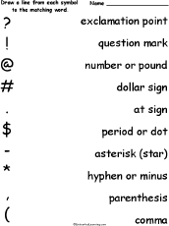  Match Symbol Words and Pictures  Match 10 symbol words to their pictures. The words are: exclamation point, question mark, number or pound sign, dollar sign, at sign, period or dot, asterisk or star, hyphen or minus, parenthesis. Or go to the answers.
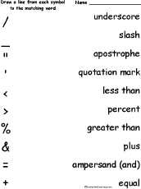  Match Symbol Words and Pictures #2  Match 10 symbol words to their pictures. The words are: underscore, slash, apostrophe, quotation mark, less than, percent, greater than, plus, ampersand (and), equal. Or go to the answers. | 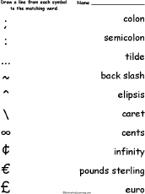  Match Symbol Words and Pictures #3  Match 10 symbol words to their pictures. The words are: colon, semicolon, tilde, backslash, elipsis, caret, infinity, pounds sterling, euro. Or go to the answers. | 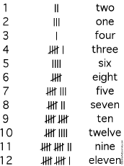  Tally Marks Matching Printout  Draw lines between the matching tally marks and numbers. Or go to the answers. | 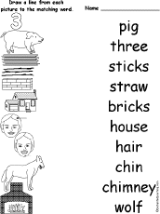  Match Three Little Pigs Words and Pictures  Match 10 Three Little Pigs-related words to their pictures. The words are: pig, three, sticks, straw, bricks, house, hair, chin, chimney, wolf. Or go to the answers.
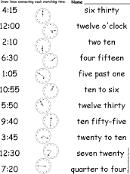  Match the Time: Digital to Analog to English: Printout  Draw lines between the time expressed in analog, digital and English. For example, match 4:15 to an analog clock picturing that time, to "four fifteen." Or go to the answers. | 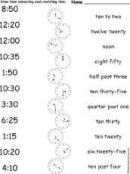  Match the Time #2: Digital to Analog to English: Printout  Draw lines between the time expressed in analog, digital and English. For example, match 1:50 to an analog clock picturing that time, to "ten to two." Or go to the answers. | 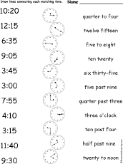  Match the Time #3: Digital to Analog to English: Printout  Draw lines between the time expressed in analog, digital and English. For example, match 3:45 to an analog clock picturing that time, to "quarter to four." Or go to the answers. | 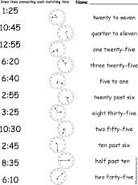  Match the Time #4: Digital to Analog to English: Printout  Draw lines between the time expressed in analog, digital and English. For example, match 6:40 to an analog clock picturing that time, to "twenty to seven." Or go to the answers.
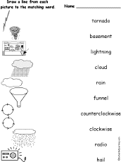  Tornado Words Matching Printout  Draw lines between each tornado word and its picture. The words are: tornado, basement, lightning, cloud, rain, funnel, counterclockwise, clockwise, radio, hail. Or go to the answers. | 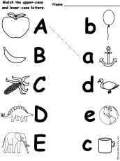  Match Upper-Case and Lower-Case Letters: A-Z  Match the upper-case and lower-case letters from a to z on five printouts. Go to a pdf file containing all 5 printable pages. | 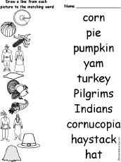  Match Thanksgiving Words and Pictures  Match 10 Thanksgiving vocabulary words to their pictures. The words are corn, pie, pumpkin, yam, turkey, Pilgrims, Indians, cornucopia, haystack, and hat. Or go to the answers. | 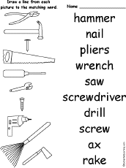  Match Tool Words and Pictures  Match 10 tools to their pictures. The words are: hammer, nail, pliers, wrench, saw, screwdriver, drill, screw, ax, rake. Or go to the answers.
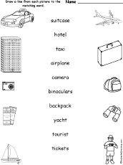  Match Vacation Words and Pictures  Match 10 vacation-related words to their pictures. The words are suitcase, hotel, taxi, airplane, camera, binoculars, backpack, yacht, tourist, tickets. Or go to the answers. | 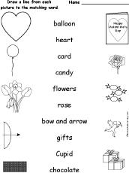  Match Valentine Words and Pictures  Match 10 Valentines Day words to their pictures. The words are balloon, heart, card, candy, flowers, rose, bow and arrow, gifts, Cupid, chocolate. Or go to the answers. | 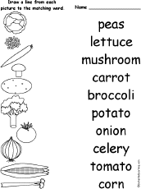  Match Vegetable Words and Pictures  Match 10 vegetable words to their pictures. The words are vegetables, peas, lettuce, mushroom, carrot, potato, onion, celery, tomato, corn. Or go to the answers. | 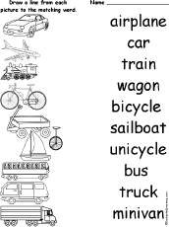  Match Vehicles and Pictures  Match 10 vehicles to their pictures. The words are: car, airplane, train, bicycle, wagon, unicycle, sailboat, bus, truck, minivan. Or go to the answers.
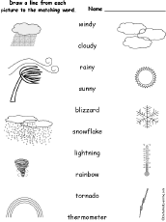  Match Weather Words and Pictures  Match 10 weather-related words to their pictures. The words are windy, cloudy, rainy, stormy, sunny, blizzard, snowflake, lightning, rainbow, tornado, thermometer. Or go to the answers. | 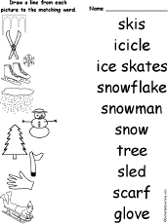  Match Winter Words and Pictures  Match 10 winter vocabulary words to their pictures. The words are: skis, icicle, ice skates, snowflake, snowman, tree, sled, scarf, and glove. Or go to the answers. | 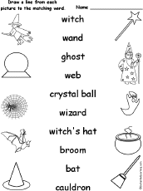  Match Witch Words and Pictures  Match 10 witch-related words to their pictures. The words are witch, wand, ghost, we, crystal ball, wizard, witch's hat, broom, bat, cauldron. Or go to the answers. | 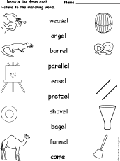  Match Words Ending in EL With Their Pictures  Match 10 words ending in el to their pictures. The words are weasel, angel, barrel, parallel, easel, pretzel, shovel, bagel, funnel, camel. Or go to the answers.
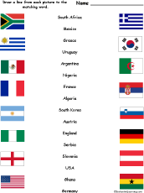
Match World Cup Soccer Countries and Flags 2010 #1
Match 10 World Cup soccer countries to their flags. The countries are Algeria, Argentina, Austria, England, France, Germany, Ghana, Greece, Mexico, Nigeria, Serbia, Slovenia, South Africa, South Korea, Uruguay, USA. Or go to the answers.
Long and Short Vowels:
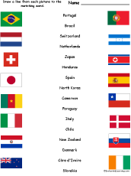  Match World Cup Soccer Countries and Flags 2010 #2  Match 10 World Cup soccer countries to their flags. The countries are Brazil, Cameroon, Chile, Cote d'Ivoire, Denmark, Honduras, Italy, Japan, Netherlands, New Zealand, North Korea, Paraguay, Portugal, Slovakia, Spain, Switzerland. Or go to the answers. | 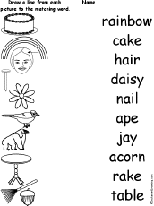  Match 'Long A' Words  Match 10 words that have the long A sound. The words are rainbow, cake, hair, daisy, nail, ape, jay, acorn, rake, table. Or go to the answers. | 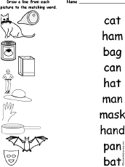  Match 'Short A' Words  Match 10 words that have the short A sound. The words are cat, ham, bag, can, hat, man, mask, hand, pan, bat. Or go to the answers. | 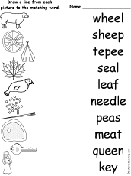  Match 'Long E' Words  Match 10 words that have the long E sound. The words are wheel, sheep, tepee, seal, leaf, needle, peas, meat, queen, key. Or go to the answers.
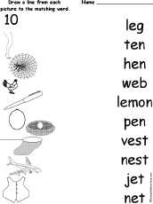  Match 'Short E' Words  Match 10 words that have the short E sound. The words are leg, ten, hen, web, lemon, pen, vest, nest, jet, net. Or go to the answers. | 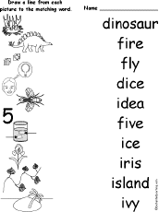  Match 'Long I' Words  Match 10 words that have the long I sound. The words are dinosaur, fire, fly, dice, idea, five, ice, iris, island, ivy. Or go to the answers. | 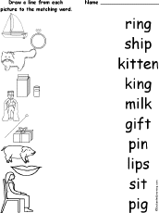  Match 'Short I' Words  Match 10 words that have the short I sound. The words are ring, ship, kitten, king, milk, gift, pin, lips, sit, pig. Or go to the answers. | 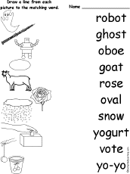  Match 'Long O' Words  Match 10 words that have the long O sound. The words are robot, ghost, oboe, goat, rose, oval, snow, yogurt, vote, yo-yo. Or go to the answers.
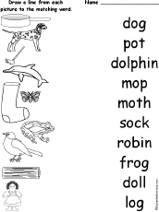  Match 'Short O' Words  Match 10 words that have the short O sound. The words are dog, pot, dolphin, mop, moth, sock, robin, frog, doll, log. Or go to the answers. | 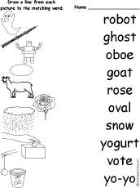  Match 'Long U' Words  Match 10 words that have the long U sound. The words are music, unicorn, cube, tube, USA, utensils, ewe, uniforms, ukulele, unicycle. Or go to the answers. | 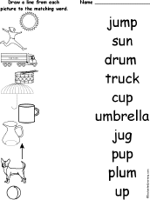  Match 'Short U' Words  Match 10 words that have the short U sound. The words are jump, sun, drum, truck, cup, umbrella, jug, pup, plum, up. Or go to the answers.
Alphabet: Match the Words and Pictures
Go to a pdf file containing all 25 printable A-Z pages (no x). or print the pages separately below (site subscribers only):
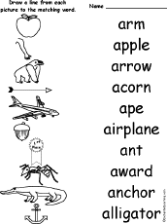  Match 'A' Words  Match 10 words that start with A. The words are arm, apple, ape, arrow, airplane, acorn, award, ant, anchor, alligator and anchor. Or go to the answers. | 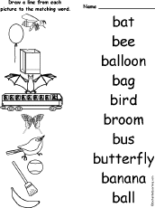  Match 'B' Words  Match 10 words that start with B. The words are bat, bee, balloon, bag, bird, broom, bus, butterfly, banana, and ball. Or go to the answers. | 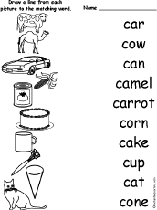  Match 'C' Words  Match 10 words that start with C. The words are car, cow, can, camel, carrot, corn, cake, cup, cat, and cone. Or go to the answers. | 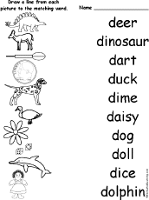  Match 'D' Words  Match 10 words that start with D. The words are deer, dinosaur, dart, duck, dime, daisy, dog, doll, dice, and dolphin. Or go to the answers.
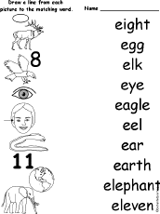  Match 'E' Words  Match 10 words that start with E. The words are eight, egg, elk, eye, eagle, eel, ear, earth, elephant, and eleven. Or go to the answers. | 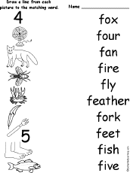  Match 'F' Words  Match 10 words that start with F. The words are fox, four, fan, fire, fly, feather, fork, feet, fish, and five. Or go to the answers. | 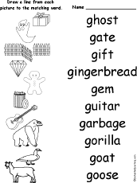  Match 'G' Words  Match 10 words that start with G. The words are ghost, gate, gift, gingerbread, gem, guitar, garbage, gorilla, goat, and goose. Or go to the answers. | 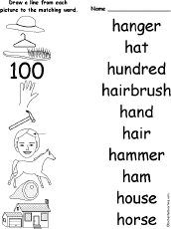  Match 'H' Words  Match 10 words that start with H. The words are hanger, hat, hundred, hairbrush, hand, hair, hammer, ham, house, and horse. Or go to the answers.
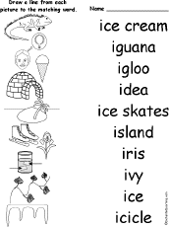  Match 'I' Words  Match 10 words that start with I. The words are ice cream, iguana, igloo, idea, ice skates, island, iris, ivy, ice, and icicle. Or go to the answers. | 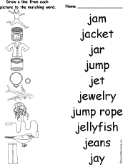  Match 'J' Words  Match 10 words that start with J. The words are jam, jacket, jar, jump, jet, jewelry, jump rope, jellyfish, jeans, and jay. Or go to the answers. | 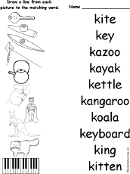  Match 'K' Words  Match 10 words that start with K. The words are kite, key, kazoo, kayak, kettle, kangaroo, koala, keyboard, king, and kitten. Or go to the answers. | 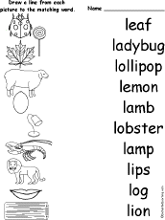  Match 'L' Words  Match 10 words that start with L. The words are leaf, ladybug, lollipop, lemon, lamb, lobster, lamp, lips, log, and lion. Or go to the answers.
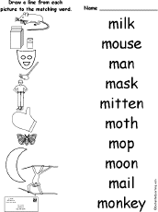  Match 'M' Words  Match 10 words that start with M. The words are milk, mouse, man, mask, mitten, moth, mop, moon, mail, and monkey. Or go to the answers. | 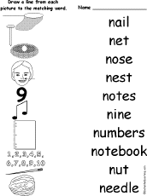  Match 'N' Words  Match 10 words that start with N. The words are nail, net, nose, nest, notes, nine, notebook, numbers, nut, and needle. Or go to the answers. | 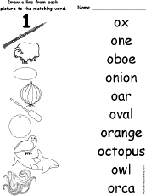  Match 'O' Words  Match 10 words that start with O. The words are ox, one, oboe, onion, oar, oval, orange, octopus, owl, and orca. Or go to the answers. | 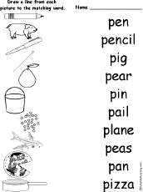  Match 'P' Words  Match 10 words that start with P. The words are pen, penci, pigl, pear, pin, pail, plane, peas, pan, and pizza. Or go to the answers.
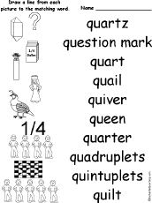  Match 'Q' Words  Match 10 words that start with Q. The words are quartz, question mark, quart, quail, quiver, queen, quarter (fraction), quadruplets, quintuplets, and quilt. Or go to the answers. | 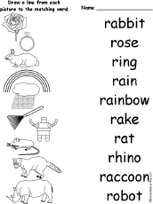  Match 'R' Words  Trace and learn to write words that start with the letter r, including rabbit, rose, ring, rain, rainbow, rake, rat, rhino, raccoon and robot. Or go to the answers. | 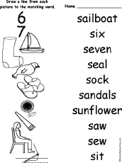  Match 'S' Words  Trace and learn to write words that start with the letter S, including sailboat, six, seven, sock, sandals, sew, sunflower, saw, sew, and sit. Or go to the answers. | 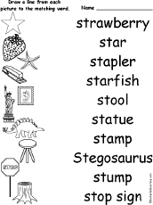  Match 'T' Words  Match 10 words that start with St, including strawberry, star, stapler, starfish, stool, statue, stamp, Stegosaurus, stump, and stop sign. Or go to the answers.
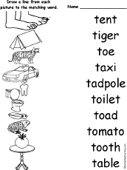  Match 'U' Words  Match 10 words that start with T. The words are tent, tiger, toe, taxi, tadpole, toilet, toad, tomato, tooth, and table. Or go to the answers. | 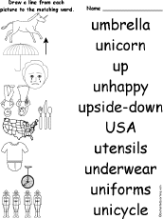  Match 'V' Words  Match 10 words that start with U. The words are umbrella, unicorn, up, unhappy, upside-down, USA, utensils, underwear, uniforms, and unicycle. Or go to the answers. | 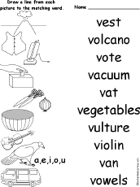  Match 'W' Words  Match 10 words that start with V. The words are vest, volcano, vote, vacuum, vat, vegetables, vulture, violin, van, and vowels. Or go to the answers. | 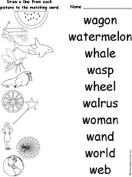  Match 'X' Words  Match 10 words that start with W. The words are wagon, watermelon, whale, wasp, wheel, walrus, woman, wand, world, and web. Or go to the answers.
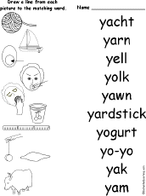  Match 'Y' Words  Match 10 words that start with Y. The words are yacht, yarn, yell, yolk, yawn, yardstick, yogurt, yo-yo, yak, and yam. Or go to the answers. | 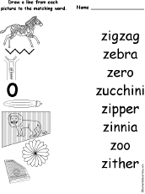  Match 'Z' Words  Match 8 words that start with Z. The words are zigzag, zebra, zero, zucchini, zipper, zinnia, zoo, and zither. Or go to the answers.

