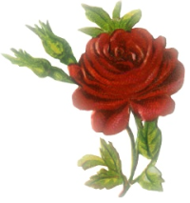
[1] Read the words and circle the right picture:
a) Seeds. |   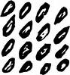  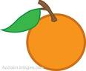
b) Pot. |   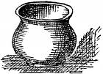  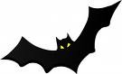
c) Meat. |   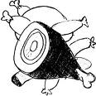  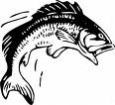
d) Carrots. | 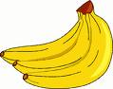  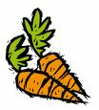  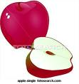
e) Pyramids. | 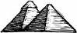  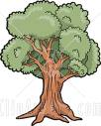  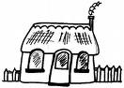

[2] Read the sentences and circle the right picture:

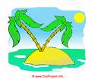
a) I went to the sea.
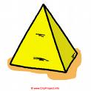

b) I like lollipops.

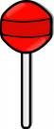
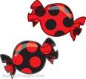

c) We need the sun.



d) Don't run in the hall.
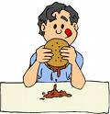

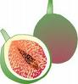
e) It's a fig.
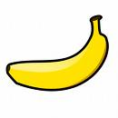

[3] Match the words with the pictures:
1- Cheese.  2- Class.  3- Olives.  4- Home.  5- Wall. | 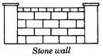  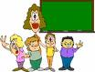    

[4] Look at the pictures, read and circle 'Yes" or "No":
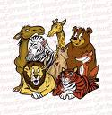
1- I went to the zoo. Yes No
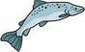
2- I like eggs. Yes No

3- This is an umbrella. Yes No
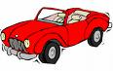
4- That is a ship. Yes No

5- I want apples, please. Yes No

[5] Look at the pictures and write the missing letters:

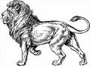



T - - l - - n - - t - andie –

[6] Look at the pictures and write the words:
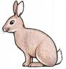
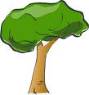
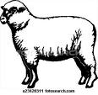

- - - - - - - - - - - - - - - - - -

[7] Copy:

Don't sleep in the class.

- - - - - - - - - - - - - - - - - - - - - - - - -

2- Put (  ) or (  ):

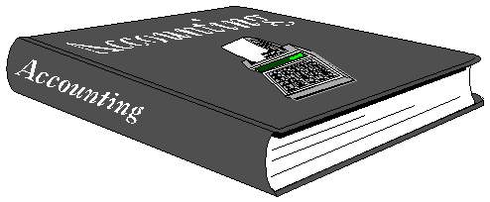
1- It is a book. ( )
2- It is an apple. ( )
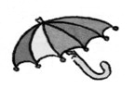
3- It is a bag. ( )

4- It is a pen. ( )
5- It is a tree. ( )
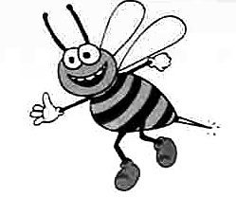
6- It is a bee. ( )
7- It is a cat. ( )
8- It is a pencil. ( )
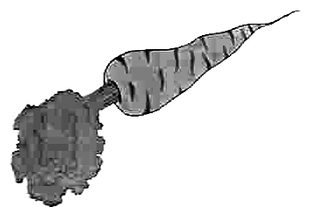
9- It is a fish. ( )

10- It is an apple. ( )
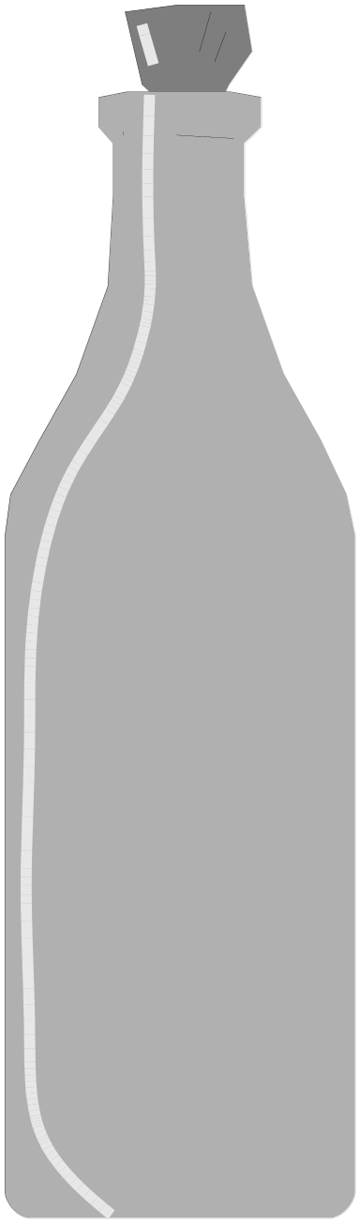
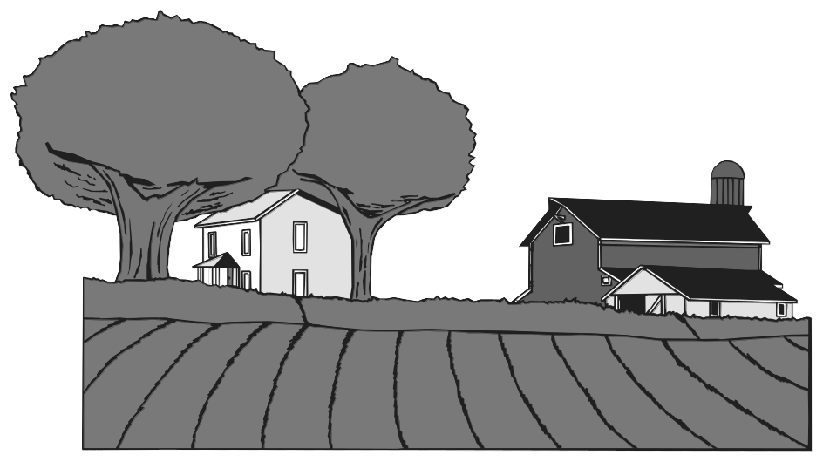
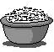

s - - - - f - - - w - - - - c - - - - - -

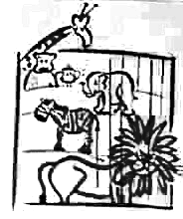
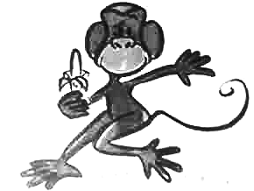
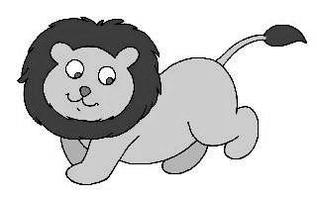

c - - - - - m - - - - - l - - - z - -
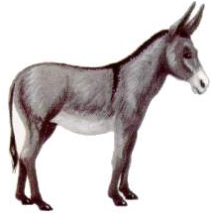
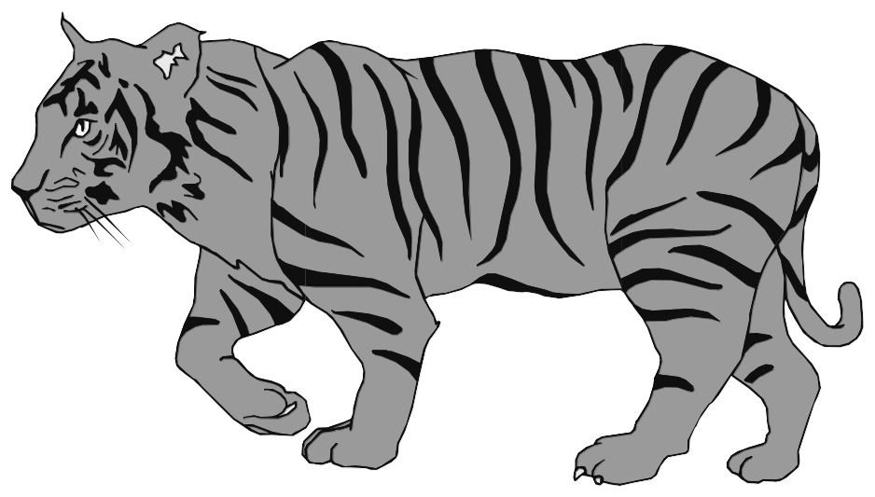
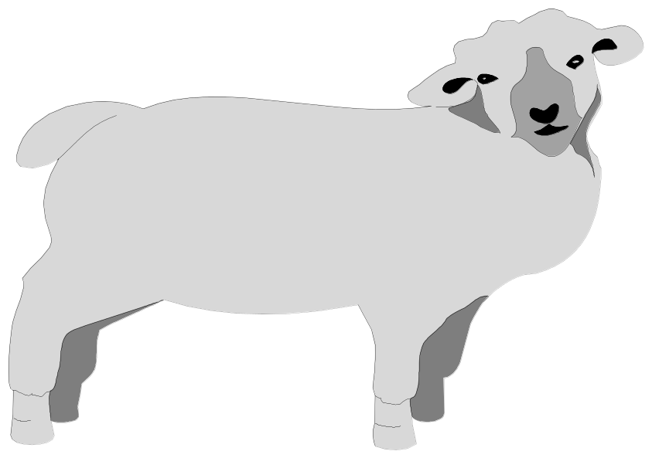

d - - - - - s - - - - z - - - - t - - - -
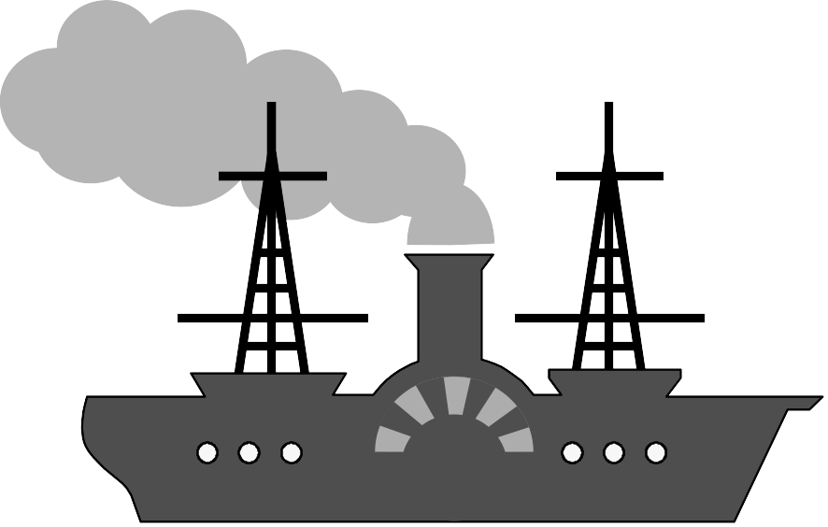
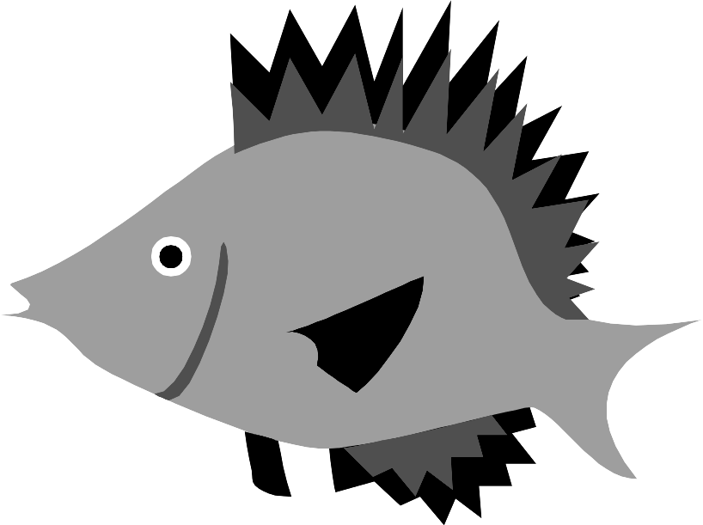
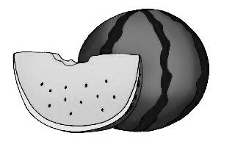
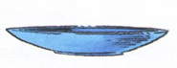

w - - - - - - - - - d - - - f - - - s - - -

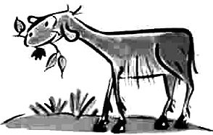
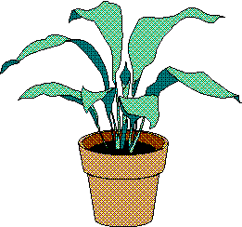

p - - - - - - - H - - - - - - p - - - - g - - -

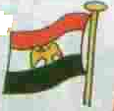
1- Write the words:
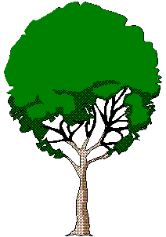

s - - - - - - - t - - - f - - - - s - - - - -

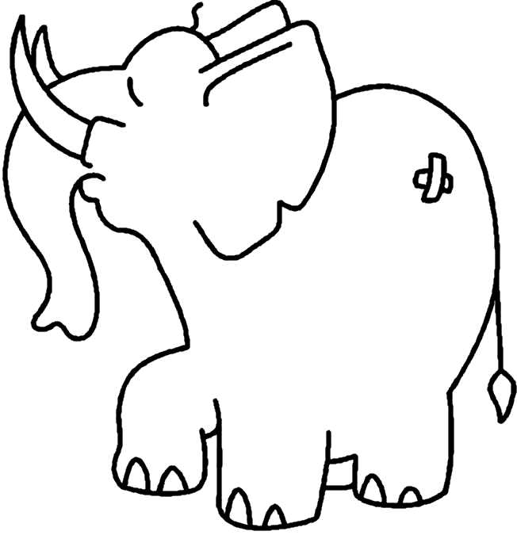

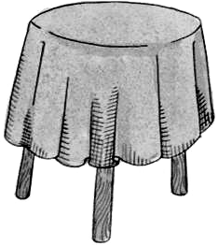

s - - - - e - - - - - - - t - - - - b - - - - -

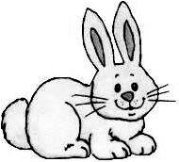
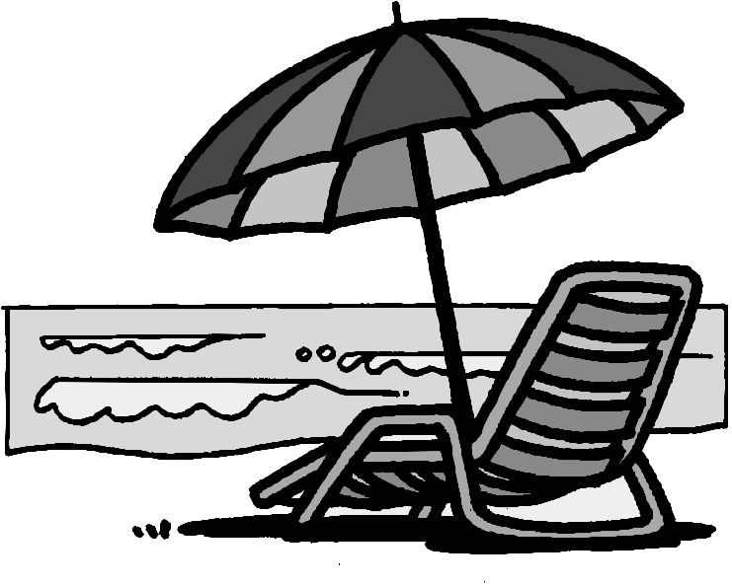
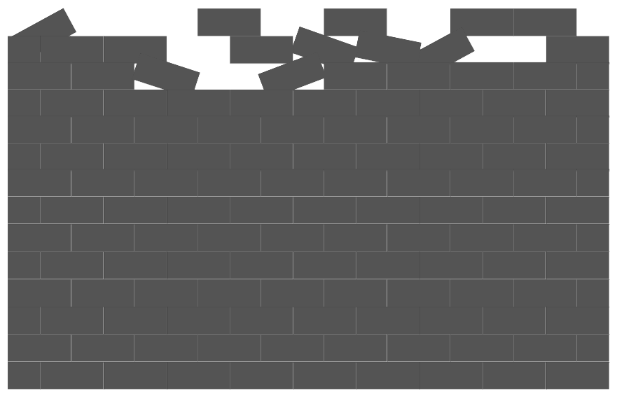

r - - - - - s - - - - - u - - - - - - - w - - -
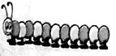

g - - - - - - h - - - - t - - - - c - - - - - - - - - -

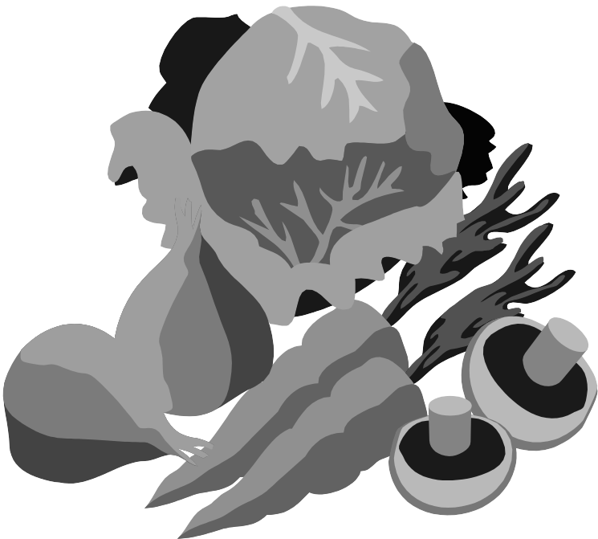
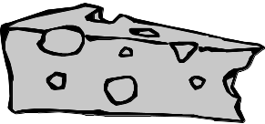

c - - - - - c - - - - - - c - - - - - v - - - - - - - - -

Look at the pictures and write the missing letters and words:
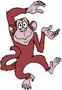
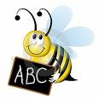


Ba--nas | b-- | ha--d | mon--y

bo-k | g-a- | f--h | To--to

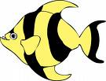
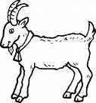


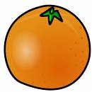



r-- | s-e--p | --t | ora--ges
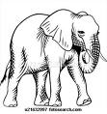
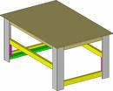
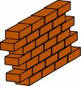
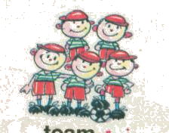

w--l | t-b-le | Fa--ly | elep-an-

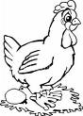
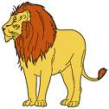
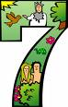

l-o- | s-v-n | h-- | tr--
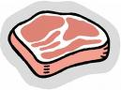

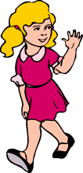


--es | g--l | car--t | m—t

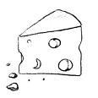

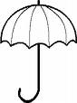

h-t | ch--se | ap--e | umb--lla



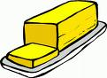


br--d | bu--er | Lo-l-pop | p-n-il
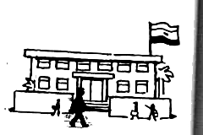
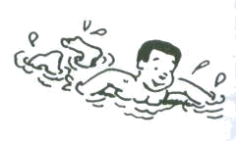
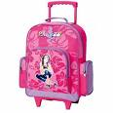
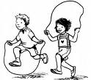

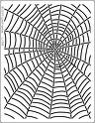
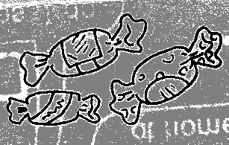
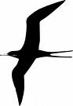
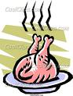





Look at the pictures, read and circle (Yes) or (No):

1- He is watching T V.

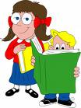
2- They are reading.
3- He is eating.

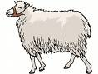
4- I can see a ship.
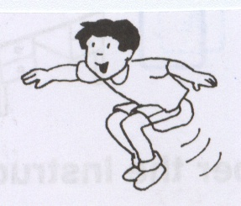
5- He is swimming.

6- He is jumping.
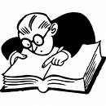
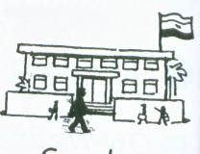
7- She is writing.

8- I went to the farm.

9- I like apples.
10- They are vegetables.
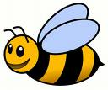
11- It can fly.
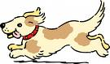
12- We saw a cat in a hat.


13- There are 3 pens.
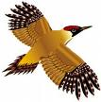
14- It can't fly.
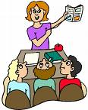
15- They are listening to the teacher.
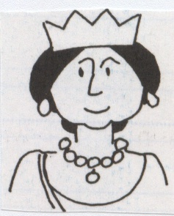
16- She is a teacher.
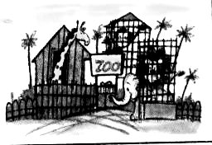
17- We went to the zoo.

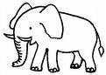
18-We see this animal in the zoo.
19- This is a boy.
20- It is a goat.
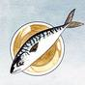
21- The fish is on the dish.
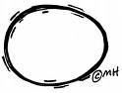
22- Eggs are fruits.
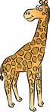
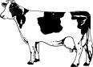
23- This is an elephant.

24- It has a short neck.
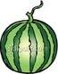
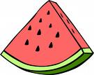
25- I like watermelon.
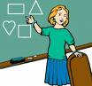
26- She is writing.
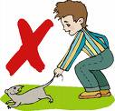
27- This is a good boy.

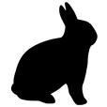
28- The rabbit is white.
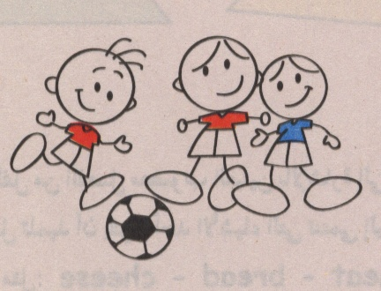
29- They are writing.

30- She is cooking.
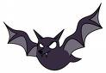
31- A bat is black.

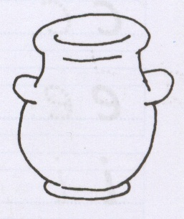
32-There is no plant in the pot.

33- He is in the class.
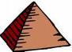

34- It is an apple.

35- This is a flower.

2- Look at the pictures. Read the word(s). Circle 'Yes' or 'No' :

1- He is a boy. Yes No
2- He is sleeping. Yes No
3- Don't run in the hall. Yes No
4- It is a hat . Yes No
5- He is reading. Yes No

2- Look at the pictures and the letters, then write the words: (4 Marks)
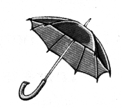
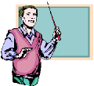
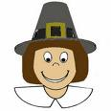

…………… …………… ………………. ………………

- Match the words in (column A) with the pictures in (column B):
team | 
carrot | 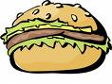  
lollipops | 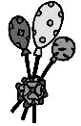
bread
pot
sandwich
Task (3) ( 9 ) marks
3- Look at the pictures, the letters and say the words:
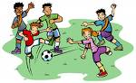
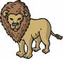

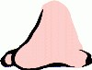

…………….. ……………. …………. …………….
Match the words in (column A) with the pictures in (column B):

Donkey |   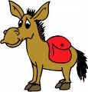
Carrot
book
Jump
Bat
Sing
3 -Read and match the words with the pictures:

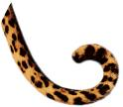
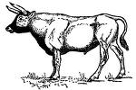
leg
tail
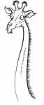

ox
neck
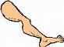
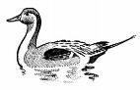
duck
queen

4-look at the pictures, read and circle (Yes) or (No):-
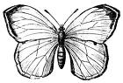
1- A butterfly can fly.
2 - I saw a fish in the dish.
3- It is small.

4- She is a teacher.

5-look at the pictures and write the missing:
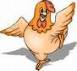

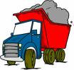
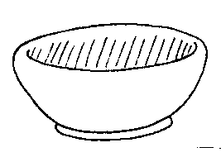

di-- | tr--k | h-- | h-n
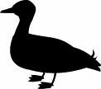

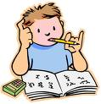


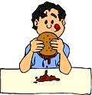
[3] Match:-

1- eat
2- butterfly

3- butter
4- sandwich


[4] look at the pictures, read then circle (yes) or (no) :-

1- This is a tree (Yes) (No)
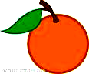
2- I want an apple, please. (Yes) (No)

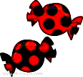
3- Don't eat candies. (Yes) (No)

[5] Look at the pictures and write the words:

…………………….. …………………
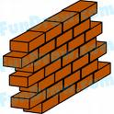

[5] Look at the pictures and Finish the words:

Wa - - fl - -
[9] Copy the following sentence:-
Don't eat in the classroom.

………………………………………………………………………

[1] Match:-
1- giraffe
2- umbrella
3- butter
4- watermelons

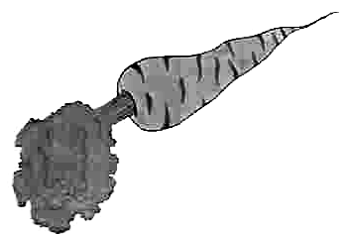
[2] look at the pictures, read then circle (yes) or (no) :-

1- This is a carrot (Yes) (No)
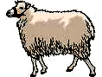
2- This sheep can fly. (Yes) (No)
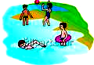

3- I was at home. (Yes) (No)

4- I like vegetables. (Yes) (No)

[3] Look at the pictures and write the words:

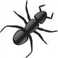

……………………. ……………… ………………..
[5] Copy the following sentence:-
On Tuesday I saw a bat on a mat.

-Read and match the words with the pictures:
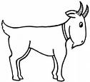

tomatoes
queen


fish

cheese
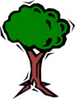
water
goat

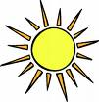
4-look at the pictures, read and circle (Yes) or (No):-
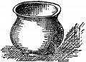
1- Put the pot in the sun.

2- I can see beans.
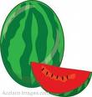
3- I like watermelon.
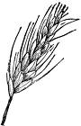
4- Can I have butter, please?

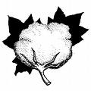
5-look at the pictures and write the missing:
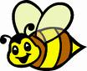
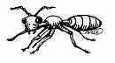

a-t | s-n | co--on | b--

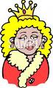
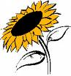

1-Listen and choose the right picture:
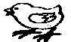
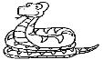
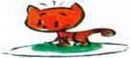
a-a snake
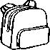
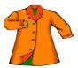

b- bag

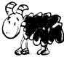
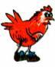

C-- a cow



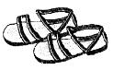
d- socks
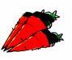
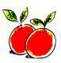

e-carrots
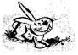
2-Look at the picture, Listen and choose the right picture:
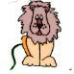
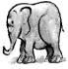
a-This is a rabbit


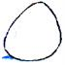

b-I like eggs.

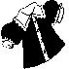
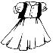
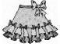
c- Look at my dress.

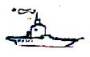
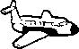
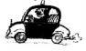
d- I can see a ship



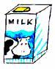
e- My brother drinks tea.

3- Match the in column (A) with the correct pictures in column (B)
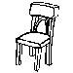
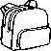
1- tree
2- bag

3- chair
4- bottle
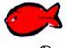
5- fish
6- flower

4-Look at the picture, read the sentences and circle Yes or N0
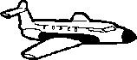
1-It is a kite Yes No

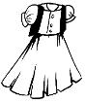
2-Look at this dress Yes No
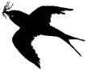

3-I can see abird Yes No

4-There is ahouse Yes No

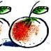

5-Those are oranges Yes No

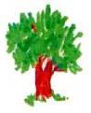
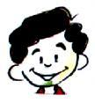
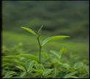
5- Look at the pictures and write the missing Letters:

1- sh - -p 2- t - - e 3- f - - e 4-Pl--t

6- Look at the pictures and write the words

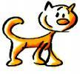
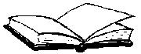

1-………… 2-…………… 3-……………… 4-……………

Copy the following sentence in good hand writing
We read and write English every day.
…………………………………………

1-Match the words with the pictures:
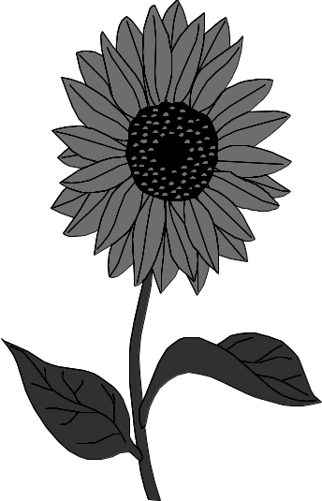
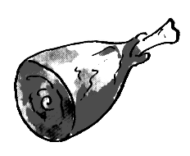
1- sunflower
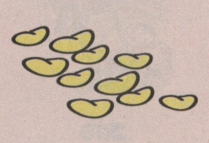
2-zebra
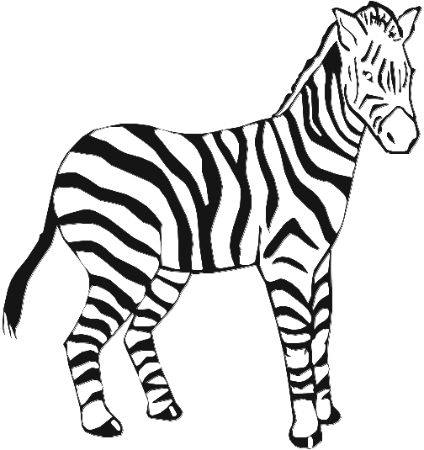
3-meat
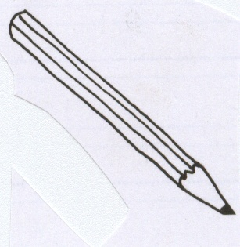
4-pencil
5-seeds
2--Look at the pictures and write the words:
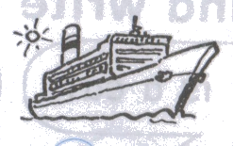 | 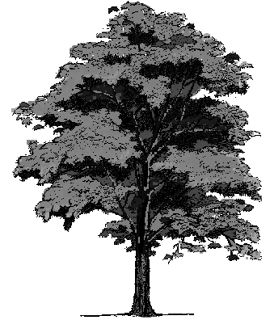  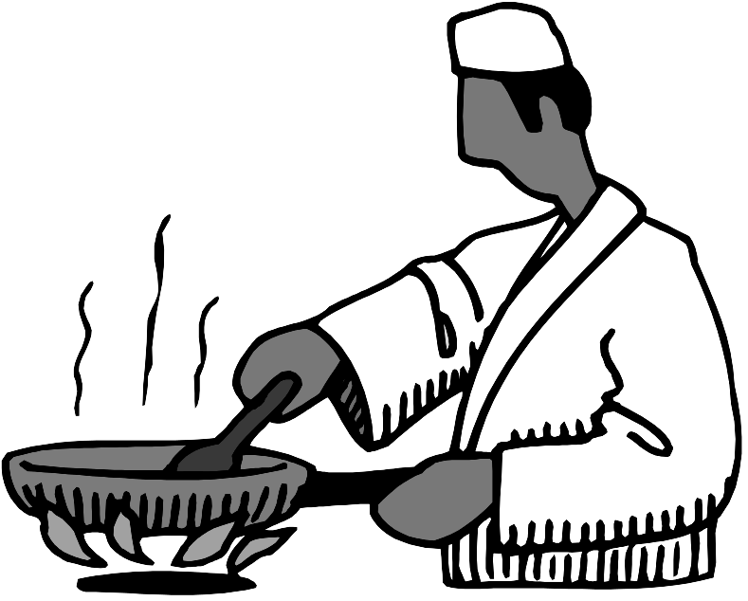 |  | 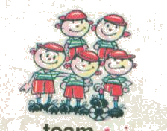
..................... | .................... | ..................... | …………….

3--Copy the sentences in good handwriting:
Pyramids are in Giza.

words and circle the right picture:
  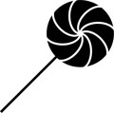  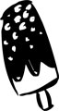 | a) Candies
   | b) cheese
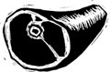  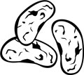   | c) meat
(2) Read the sentences and circle the right picture:

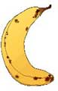

a) Can I have an apple, please?

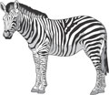
b) Its a lion.





c) Don't sleep in the class.


(3) Match:

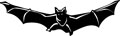
Wall
Tree
hut
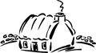
bat
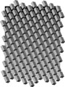
fit



(4) Look at the picture and write the missing letters:



Fl - - t - - di - - c - -


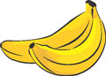
(5) Look at the pictures and write the words:



20

(1) Read and circle the right picture:
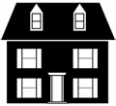  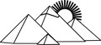   | a) Pyramids.
  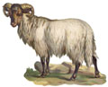 | b) Ship.
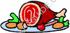 | c) Meat.

(2) Read the sentences and circle the right picture:
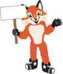
a) I went to the sea in the summer.
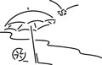


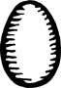
b) Can I have two eggs, please?

c) Four bags.
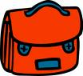
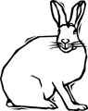
(3) Match the words with the pictures:

Chicken
Sheep

dish
hat
rabbit

(4) Look at the pictures and write the missing letters:
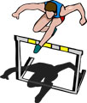

- - mp - - sh t - - - - nanas
(5) Look at the pictures and write the words:
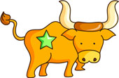
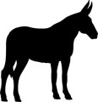
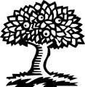
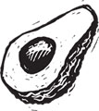

[1] Look at the pictures, read and choose one picture:
  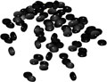  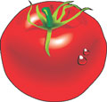 | a) Seeds.
  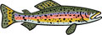 | b) Flower.
  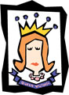 | c) Queen.
[2] Look at the pictures, read and choose one picture:

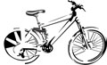
a) We need pot.


b) Can I have cheese, please?



c) I like watermelon.

[3] Match:
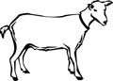
Sun
Tree

Tea
dish
goat
[4] Write the missing letters:

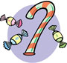

- - ange candi - - - - ip - - nkey


[5] Write the words:

Put the seeds in the pot.
- - - - - - - - - - - - - - - - - - - - - -

Look at the pictures, read and choose one picture:
  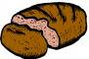   | a) Sugar.
  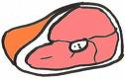 | b) Water.
   | c) Farm.
  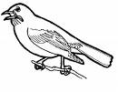 | d) Ox.
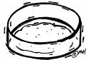 | e) Dish.
   | f) Box.

Look at the pictures and write the words:
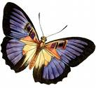

- - - - - - - - - - - - - - - - - - - - - - - - - - - - -

Look at the pictures, read and choose one picture:
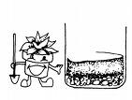
a] put the seeds in the soil.
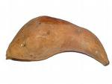
b] He likes sweet potatoes.
c] We need a box.
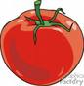

d] It's a fruit.
e] It's a vegetable.

Match the words with the pictures:
Tomatoes
Pot
Candies
Farm
Tree
Look at the pictures and write the words:

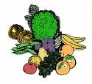
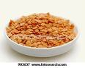

- - - - - - - - - - - - - - - - - - - - - - - - -
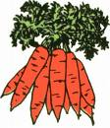
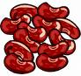

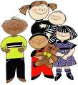

- - - - - - - - - - - - - - - - - - - - - - - - - - -

Copy the following sentence:
Don't put seeds in the sun.
- - - - - - - - - - - - - - - - - - - - -
Put the seeds in the pot.
- - - - - - - - - - - - - - - - - - - - - -
She likes fruit and vegetables.
- - - - - - - - - - - - - - - - - - - - - -
He likes watermelons.

                     

